SDLC Model:

https://existek.com/blog/sdlc-models/?fbclid=IwAR1mn-BWL-teXsRXTb77eSdyZvs0qlev3Ir5morKq2RCY-wPtmCL6IsXi5Y

SQL

<https://artoftesting.com/sql-queries-for-interview>

<https://www.techbeamers.com/sql-query-questions-answers-for-practice/>

edureka.co/blog/interview-questions/sql-query-interview-questions

1. Regrex site: <https://www.jrebel.com/blog/java-regular-expressions-cheat-sheet>
2. JAVA:

* To check java version: java -version
* jar- java archival files

1. EclipseKapler

* JDK 64 bit—Eclipse 64/32 bit
* JDK 32 bit---Eclipse 32 bit

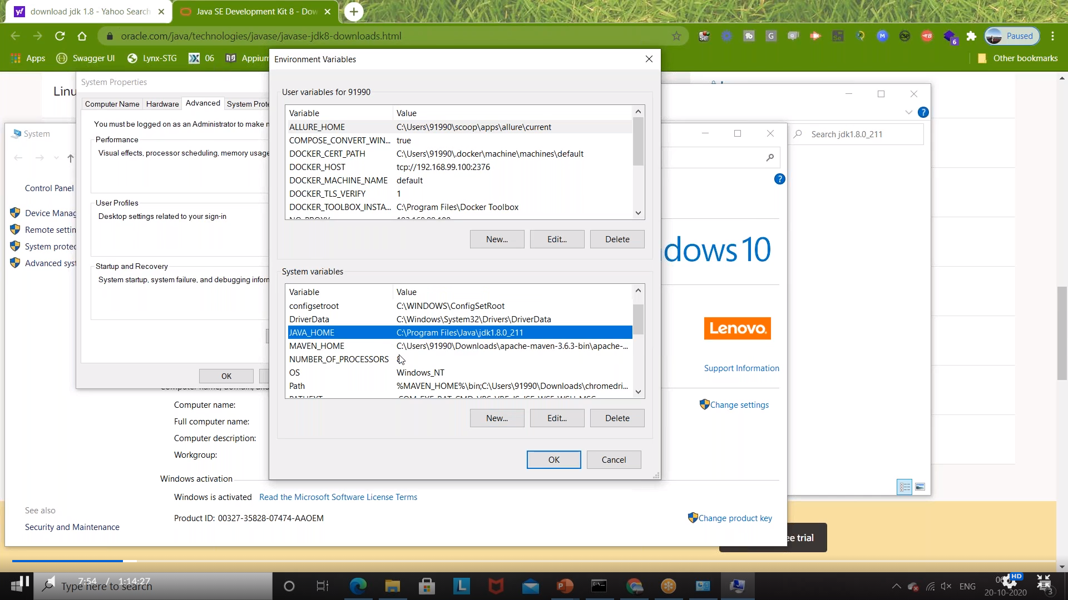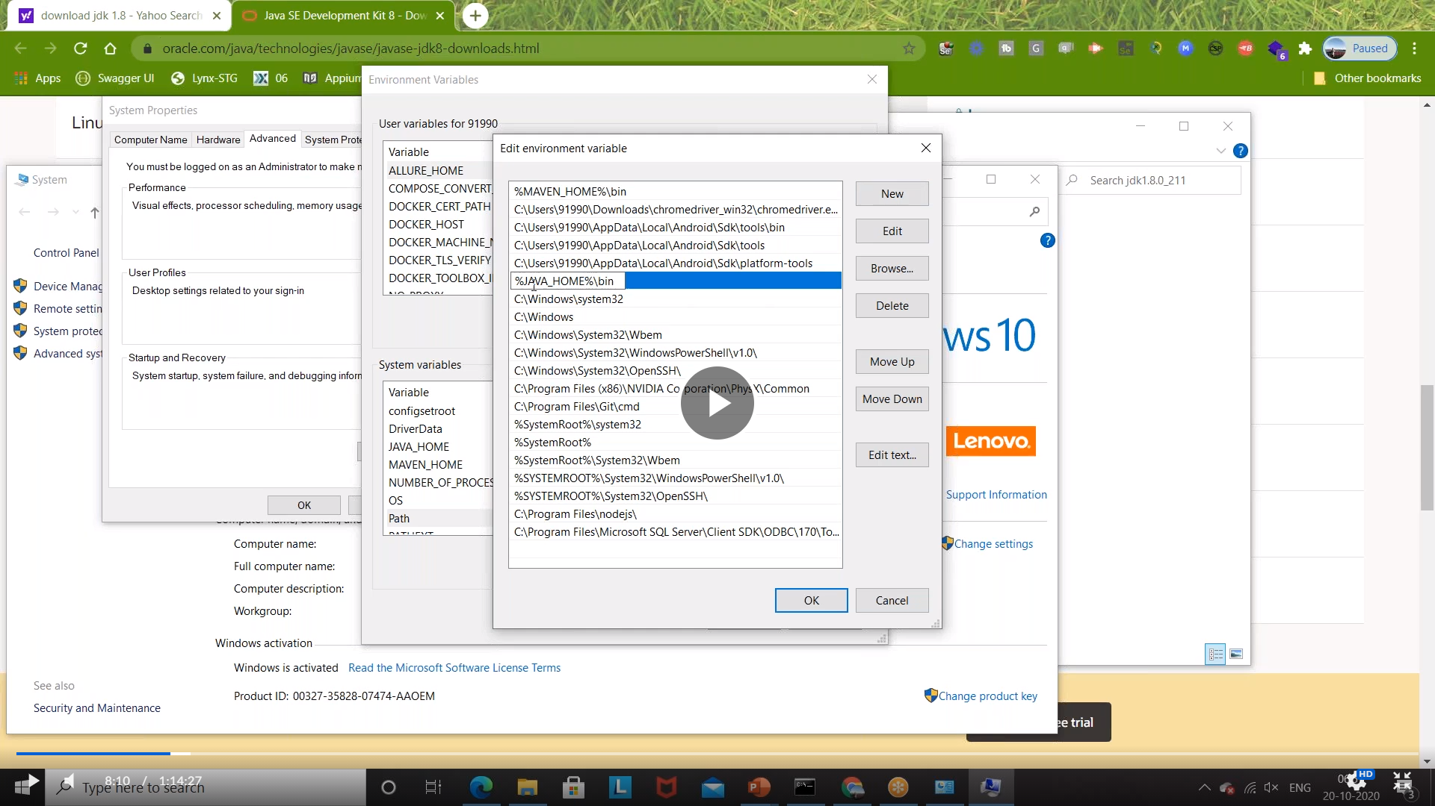

Java memory FAQ:

How do I control the amount of memory my Java program uses (i.e., Java RAM usage)?

The short answer The short answer is that you use these Java command-line parameters to help control the RAM use of application: Use -Xmx to specify the maximum heap size Use -Xms to specify the initial Java heap size Use -Xss to set the Java thread stack size If Java process exceeds -Xmx memory size, then you will java.lang.OutOfMemoryError.

**Java heap size description(xms,xmx,xmn)**

**-Xms size in bytes**

* Sets the initial size of the java heap.
* The default size is 2MB
* The values must be multiple of grater than 1024bytes(1KB)
* The –sever flag increase the default size to 32M

**-Xmn size in bytes**

* Sets the initial java heap size for the Eden generation.
* The default size is 640KB
* The –sever flag increase the default size to 2M

**Xmx size in bytes**

* Sets the maximum size to which java heap can grow
* The default size is 64MB
* The –sever flag increase the default size to 128M
* The maximum heap limit is about 2GB

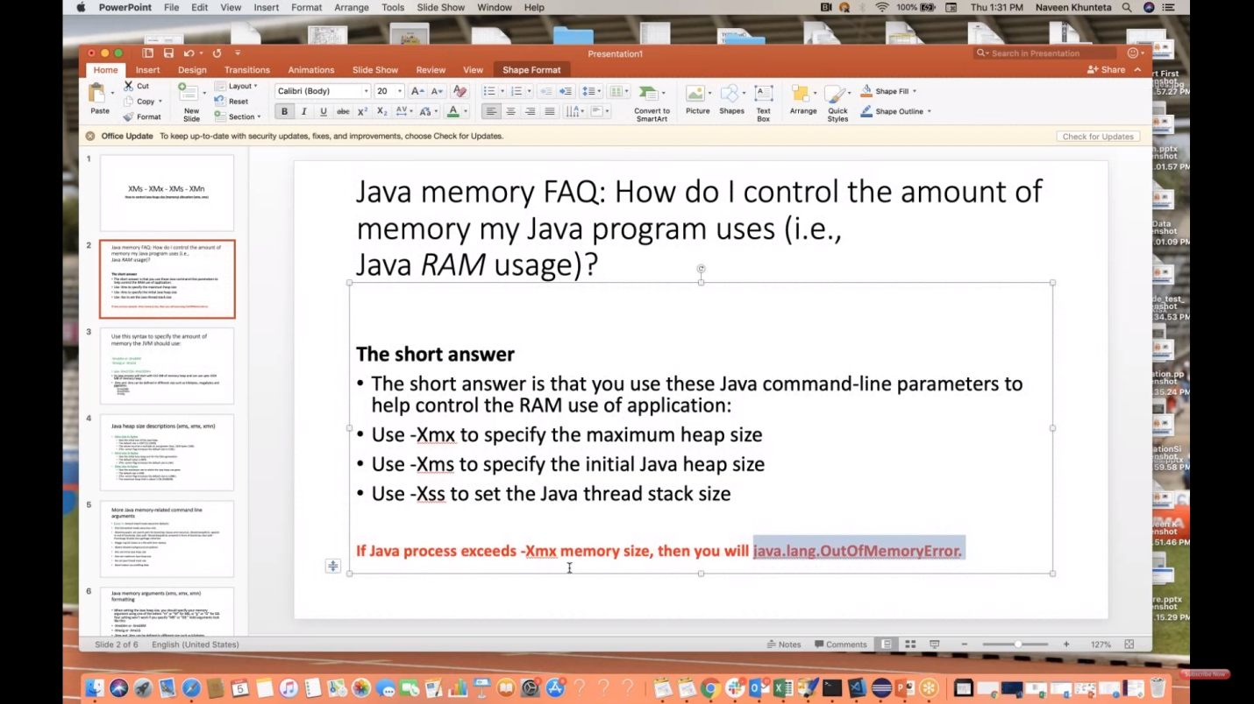

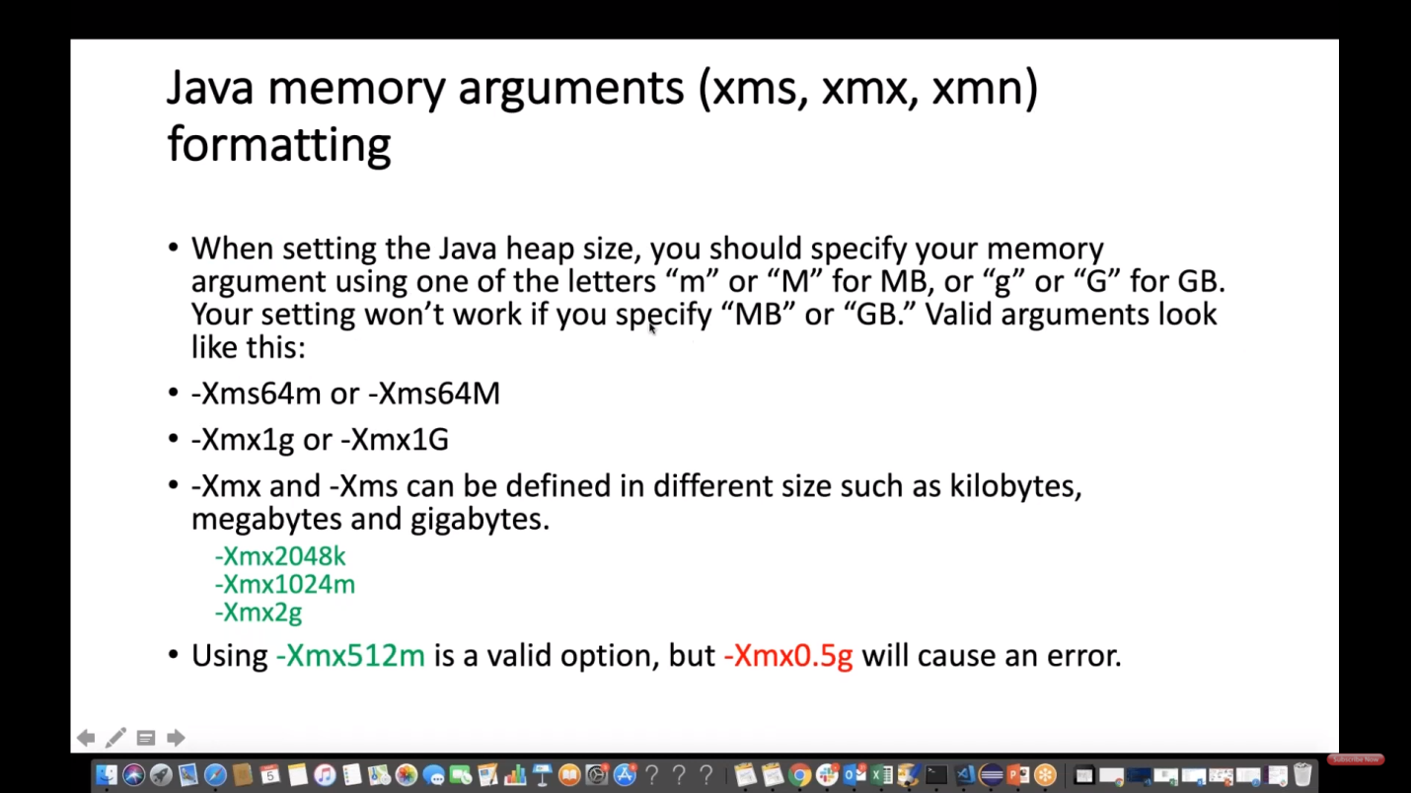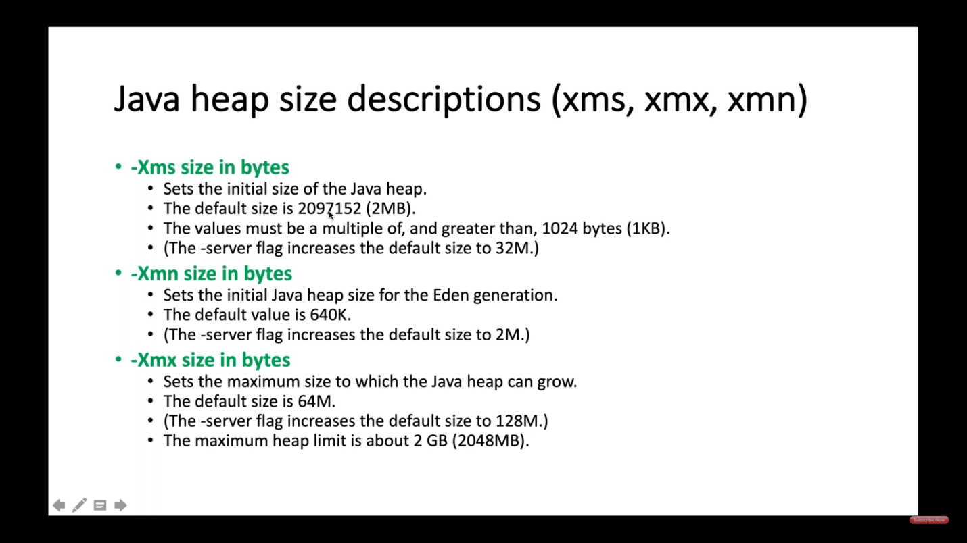

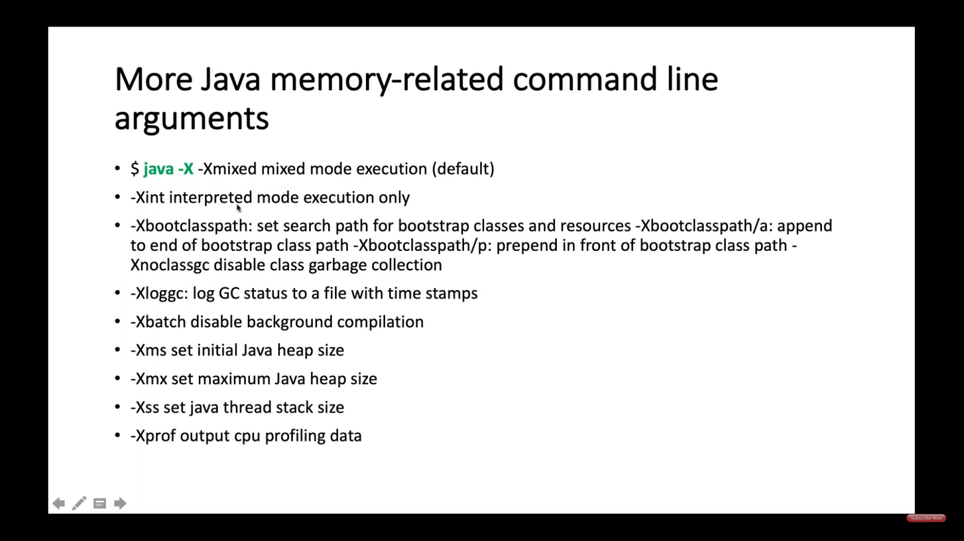

Notes:

* JVM will come inside the class and check if main is there to execute any program

1. primivitie data types: byte,short,int,long,double,float,char,Boolean

It means will be stored inside the memory without any object creation.

// data types:

// numeric data types:

// byte,short,int,long--Integer Family

// size: 1 byte: 8 bits

// range:-128 to 127

**Byte** b = 1;

b = -128;

//short:

// size: 2 bytes

// range:-32768 to 32767

**short**s = 20;

**short**s1=-32768;

**short**s3=32767;

//int:

//size: 4 bytes: 32 bits

//range:

**int**i=10;

//long:

//size: 8 bytes: 64 bits

//range:

**long**l=1299982;//(ex:population, distance between earth and moon, blood count, hairs)

//Double family

//double:

//size: 8 bytes: 64 bits

**double**d=12.33;

//float: 4 bytes: 32 bits

**float**f1=12.34f;

**float**f2=(**float**) 12.34;

//char:

//size:2 bytes

**char**c1='1';

**char**c2='$';

//boolean:~1 bit(actually less than 1 bit)

**boolean**b11=**true**;

**boolean**b12=**false**;

//String:

String st="Hellos";

1. ASCII Vales:

* //0-9:48-57
* //a-z:97-122
* //A-Z:65-90

1. System.***out***.println(5/2);//2 because both are pure integer

**char** c1='a';//97

**char** c2='b';//98

System.***out***.println(c1+c2);//195

System.***out***.println(c2-c1);//1

System.***out***.println(c1-c2);//-1

1. Dead Code:- Unreachable code

EX: //Dead code:

**if**(**true**) {

System.***out***.println("Pass");

}**else**{

System.***out***.println("False");

}

Not a dead code: //not a dead code as the compiler will check the condition

**boolean**t=**false**;

**if**(t) {

System.***out***.println("testttt");

}**else** {

System.***out***.println("heyyyy");

}

1. For loop:

//infinite loop test----This is infinite for loop

**for**( ; ; ) {

System.***out***.println("Test");

}

7. //two types of loops:

//1. while/for/do while

//2. infinite loop/storage of memory loop:pitfalls loop in java

1. Array:

* Size of array is fixed: static array:to solve this problem we use dynamic array(ArrayList)
* It can store only similar types of values, to overcome this problem we can use Object[] arr1=**new** Object[10]; but the size will be fixed again.

1. Inheritance:

* Top casting:

Ex:Car c1=new BMW();

C1.autoparking()----🡪this method is of child class BMW and c1 will not be able to see this and java checks for **reference type check.**

* BMW b2=(BMW)**new** Car();--🡪ClassCastException:runtime error

The correct way to write is BMW b2=(BMW) c1;

* Downcasting is not allowed and detected during run time itself

1. ArrayList

* Default Virtual capacity of ArrayList is 10.
* Default physical size:0 before adding anything
* add,remove - we dont need explicit synchronization
* to fetch/traverse the valuesfrom this list -- we have to use explicit synchronization
* CopyOnWriteArrayList -- its a class:Thread-safe/synchronized already:

Ex: CopyOnWriteArrayList<String> empList=new CopyOnWriteArrayList<String>();

1. MethodOverloading : it is also part of polymorphism🡪Compiletime polymorphism

* Static methods can be overloaded
* Non-static methods can also be overloaded
* Return type of methods doesnot matter in method overloading
* Within the same class, when we have diff methods with the same name and diff input parameters and sequence of the parameters is also different

**Ex:**

1. **Search🡪 in e-commerce website. It can search with name and price , then I can search with color,I can search with sellername and price and availability.**
2. **Login 🡪with username,password otp. I can also login with username ,password ,phone.**
3. **Payment:🡪goggle pay,apple pay,paypal,credit card,debit card.**
4. **Booking🡪**
5. Constructors:

* Default constructor(hidden constructor) will be called by JVM whenever new() object is created.
* But if there is parameterized constructor is created in class by the user JVM will not create default constructor and user have to create it.

1. Overridding concept or dynamic Polymorphism

* If a method is declared as final it cannot be overridden
* If a method is declared as static it cannot be overridden as it is not part of the object
* If a class is declared as final it cannot have any subclass. But it can have Superclass and extends from superclass. It means final keyword is used to prevent inheritance.

1. Interface:

* Interface variables are **static and final by default.**
* **Private and protected methods are not allowed in interface.**
* Default methods are allowed from java 1.8
* Static methods with method body are allowed from java 1.8
* Can not create the object of the interface.
* **Default methods are only allowed in interfaces. It can be overridden eventhough the method body is defined in interface.**
* Interface cannot have super class, it can only have super interface.
* Downcasting is not allowed and detected during compile time itself

1. Abstract:

* private abstract methods are not allowed in abstract class as it cannot be implemented
* private methods can be declared but cannot be used and eclipse will give warning
* protected methods are allowed in abstract class
* Cannot create object of abstract class
* Constructors can be created in abstract class
* abstract class constructor can be called, but it will be called with child class object creation
* If abstract parent class and child normal class both have constructor then first parent class constructor will be called and then child class constructor
* Abstract class without any abstract method is also allowed.

1. Encapsulation:

* To hide the data or business logic

1. String:

* If the string or char does not exist in the given string it returns -1.

1. Finally:

* even though exception didn't occur but finally block will be executed.
* Try,catch and then finally. Finally can’t be written in between try and catch.

1. Finalize method:

It is called when the object of the particular method is created and finalize method is defined there itself. But it is called only when the object is pointing to null & gc is explicitly called.

1. Local variables:

* It has to be initialized.

1. **Hashtable and hashmap Difference**

1.hashmap is not synchronized --- not thread safe

1.hashtable is syncronized

2.only 1 null key and multiple null values are allowed in hashmap

2.no null key or value in hashtable

1. **Diff bewtweenhashset and hashmap**

HashSet contains only values whereas HashMap contains an entry(key and value).

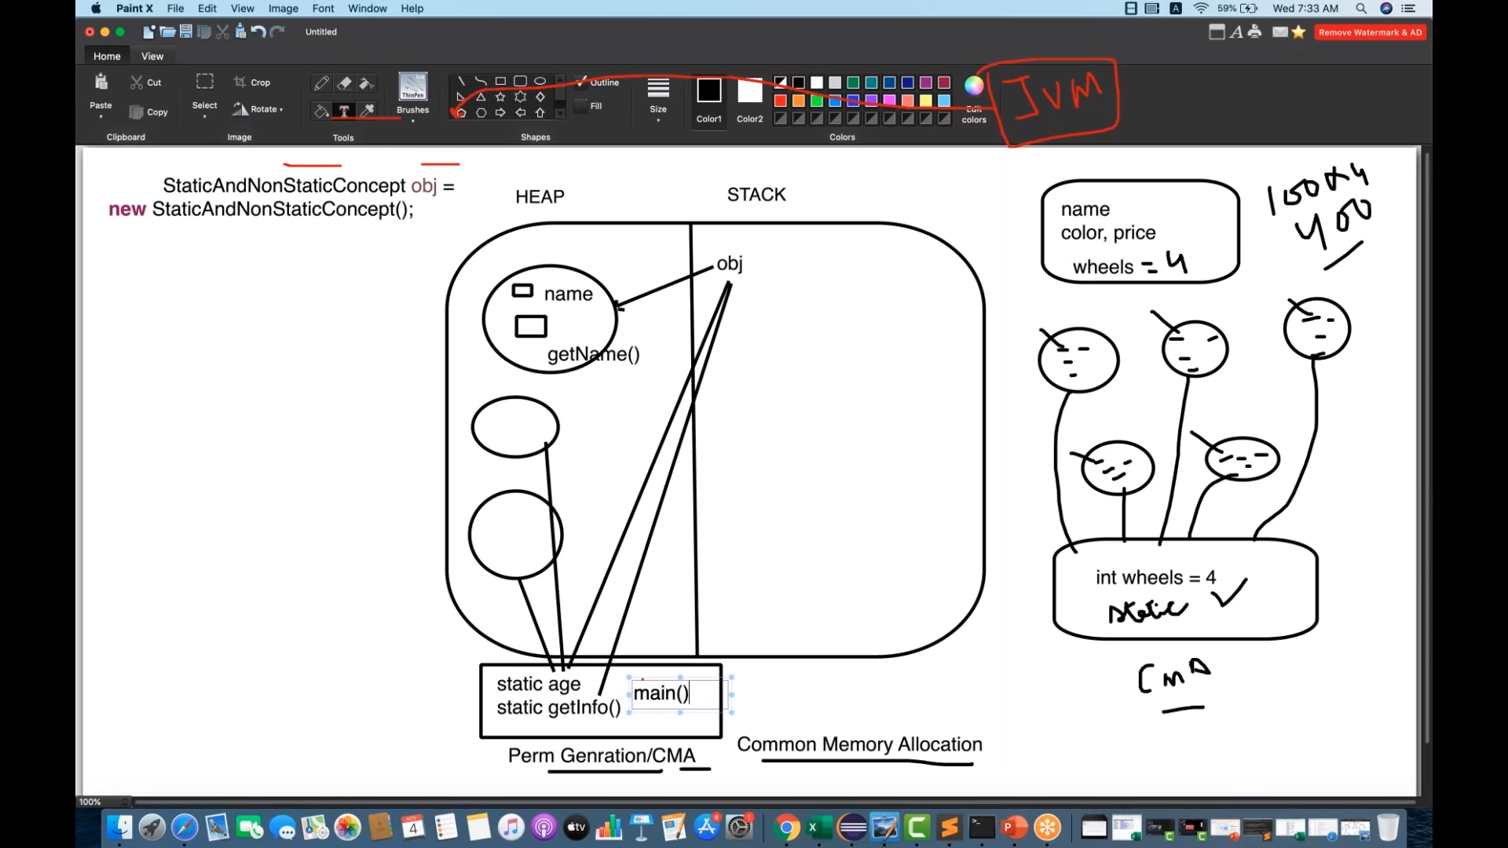

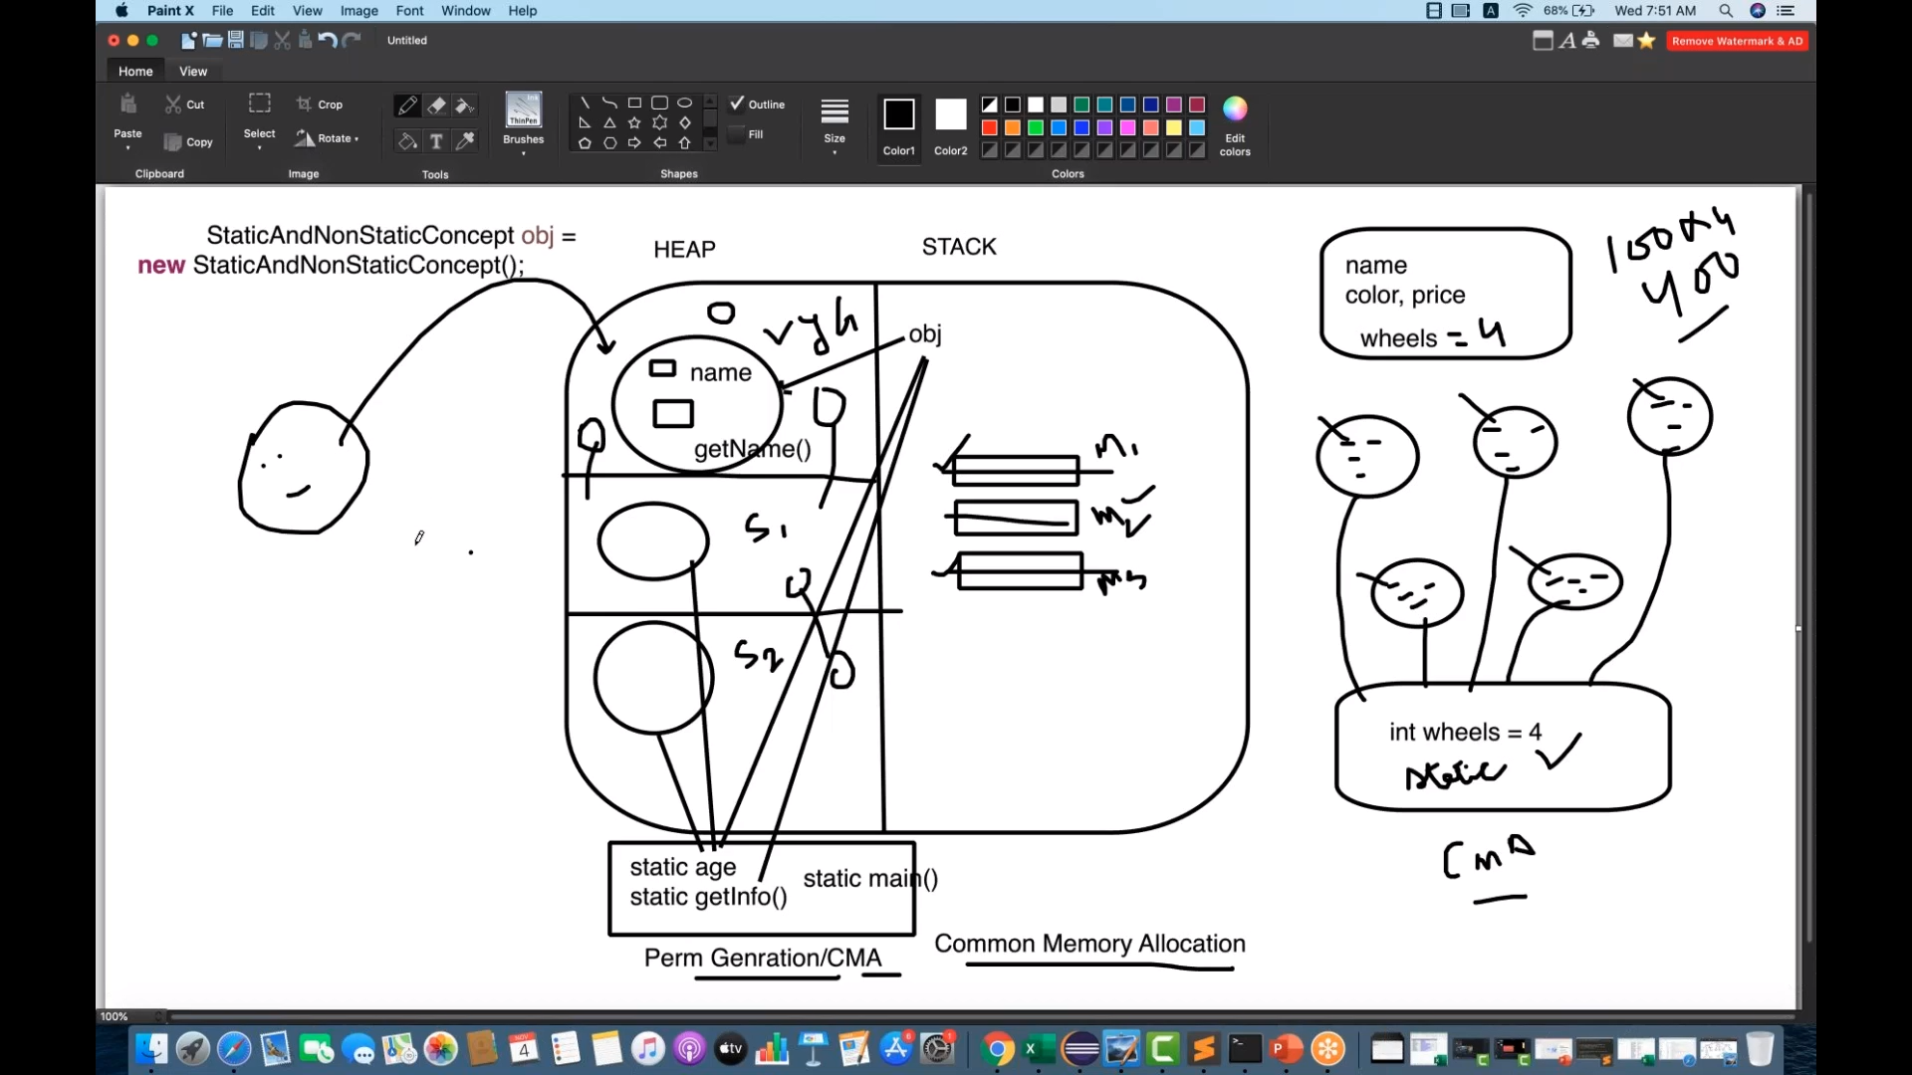

**Exceptions:**

1. ArithmeticException(divide by zero)
2. ArrayIndexOutOfBoundsException:System.***out***.println(i[-1]);//ArrayIndexOutOfBoundException
3. BMW b1=(BMW) **new** Car();//ClassCastException
4. java.lang.StringIndexOutOfBoundsException: If you try to access the character of a String at the index which is greater than its length a **StringIndexOutOfBoundsException** is thrown.
5. Arraylist of 5 data:

* System.out.println(ar.get(-1));// >ava.lang.ArrayIndexOutOfBoundsException:
* System.out.println(ar.get(6));//java.lang.IndexOutOfBoundsException

1. java.lang.NumberFormatException:

* Ex: String p="100A";
* intk=Integer.parseInt(p);

1. UnsupportedOperationException: immutableMap with only one single entry:

Map<String,Integer> map3=Collections.singletonMap("test", 100);

System.out.println(map3.get("test"));

//map3.put("test1", 200);UnsupportedOperationException

8.We can write only Throwable and its subclasses for catch block in exception.

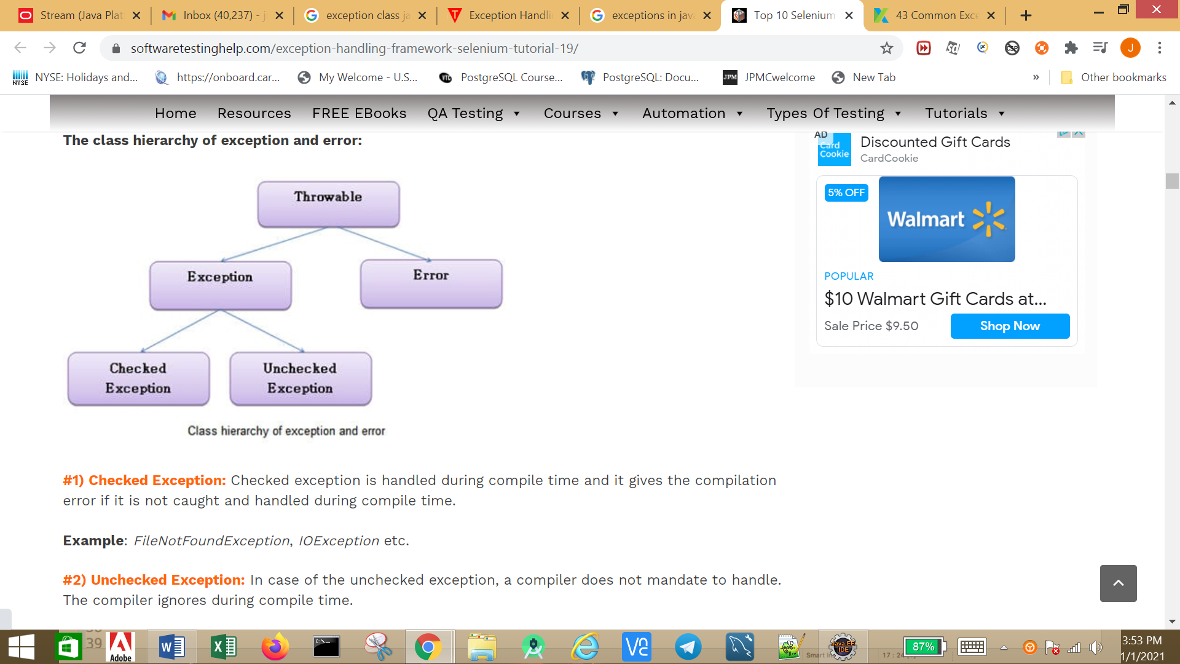

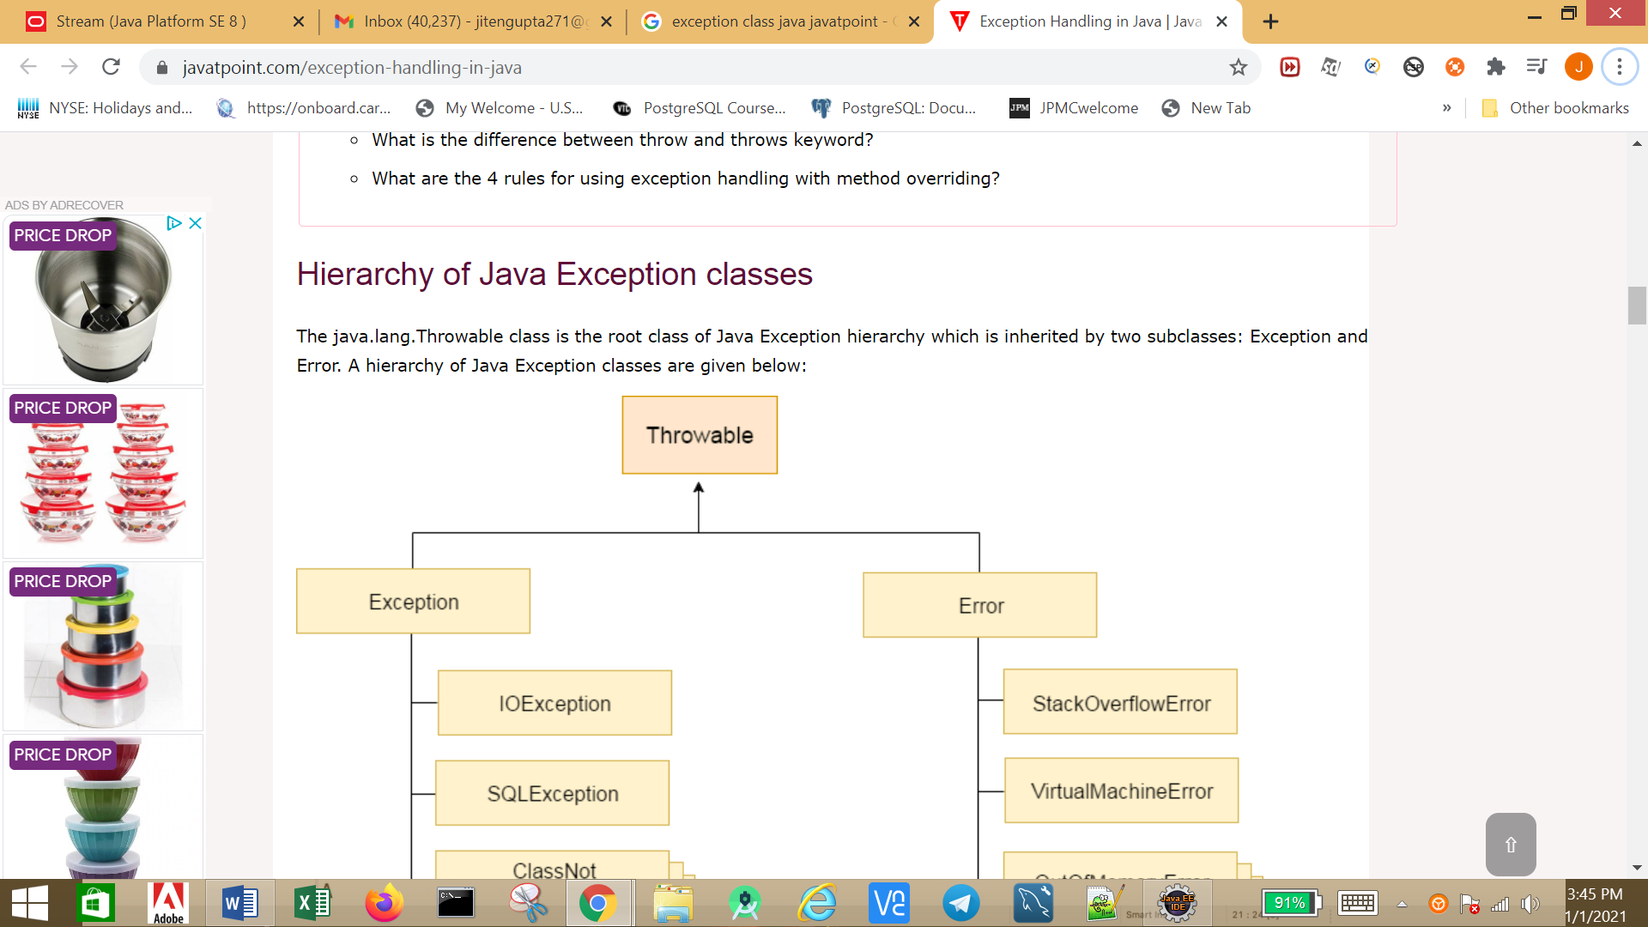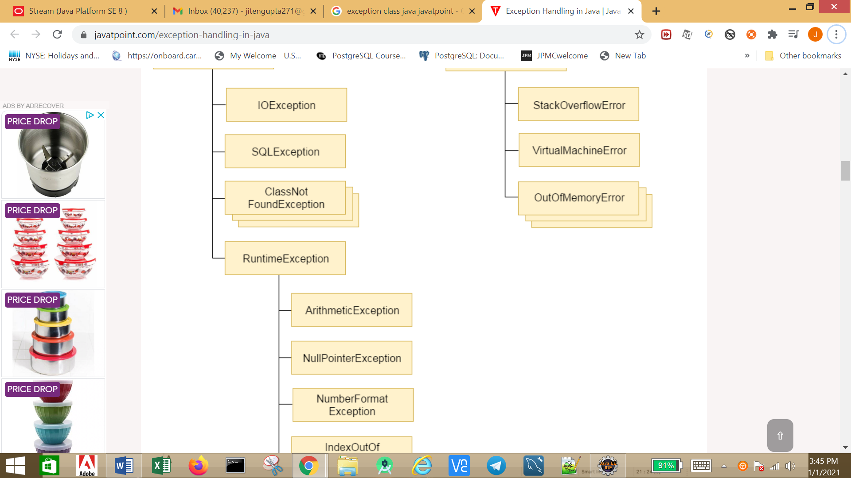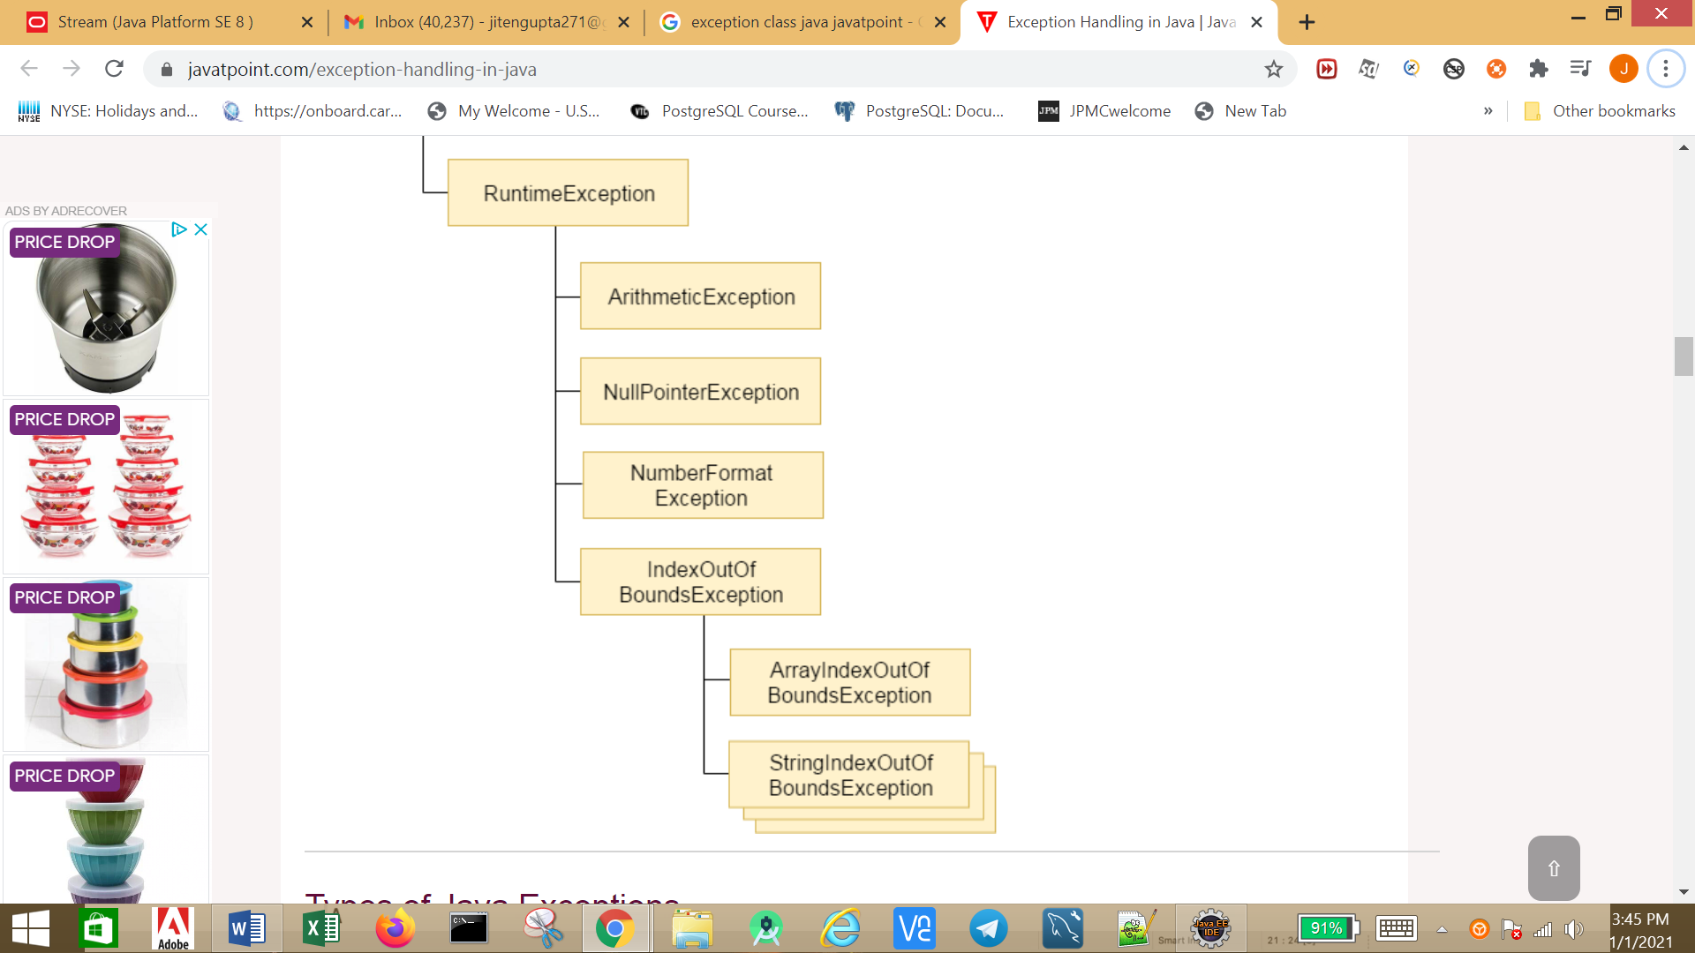

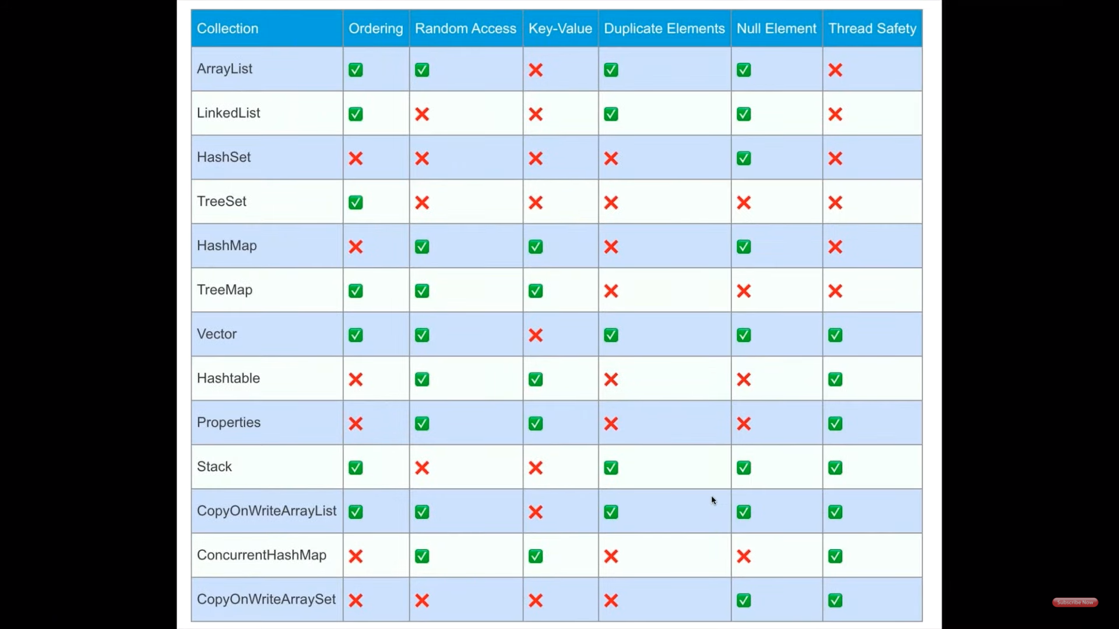

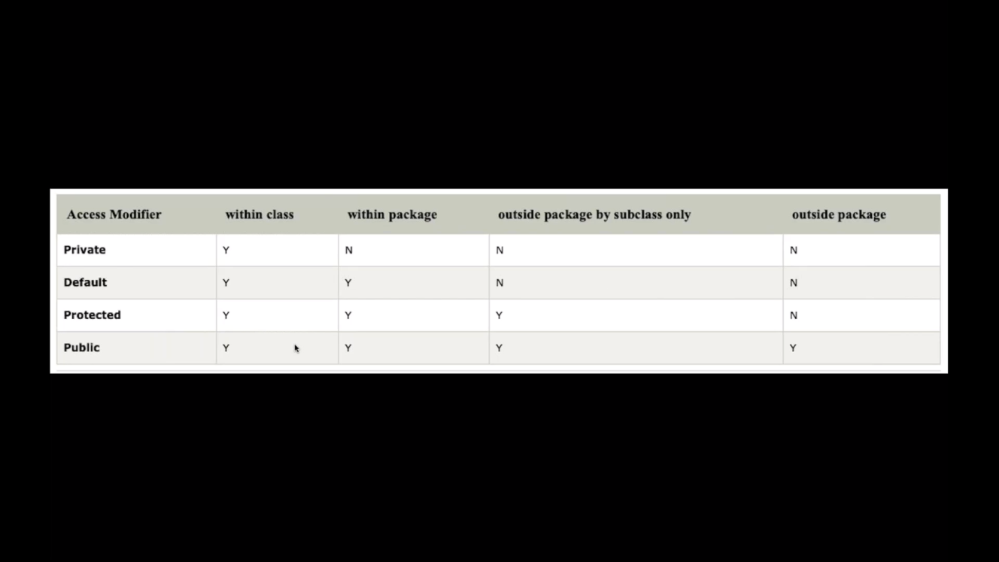

OOPS:

#### ****Difference Between Constructor Overloading and Constructor Chaining:****

|  |  |
| --- | --- |
| **Constructor Overloading** | **Constructor Chaining** |
| 1. Constructor overloading allows a class to have more than one constructor that have the same name as that of the class but differ only in terms of number or type of parameters. | 1. Constructor chaining is a process of calling the one constructor from another constructor with respect to current object. |
| 2. Constructor overloading is done to construct object in different ways. | 2. Constructor chaining is done to call one constructor from another constructor. |
| 3. Constructor overloading is achieved by declaring more than one constructor with same name but different parameters in a same class. | 3. Constructor chaining is achieved by this() method. |
| 4. Constructor overloading is flexible which allows us to create object in different way. | 4. Constructor chaining is useful when we have many constructors in the class and want to reuse that constructor. |

Collections in Java:

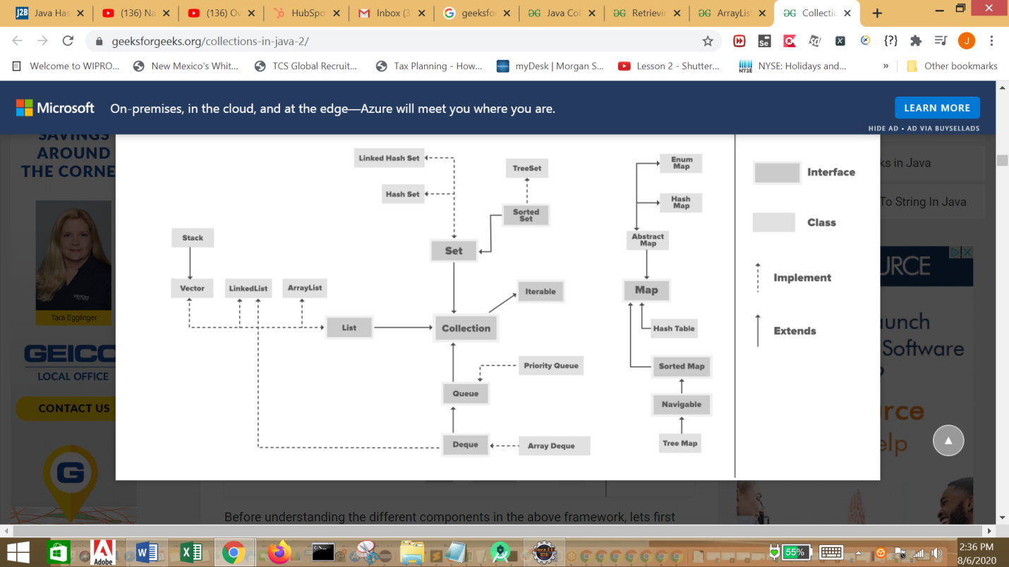

ArrayList:

**Why to choose ArrayListvs Array:**

1. Array is fixed length data structure If array is full , you can not add element to it, where asArrayList in java can dynamically grow and shrink as per our need.
2. You can use generics with ArrayList but not with Array
3. ArrayList have predefined methods which can be used to perform operations.

**Some important points about ArrayList in java are:**

1. ArrayList is implementation of list interface.
2. ArrayList is not synchonized(so not thread safe)
3. ArrayList is implemented using array as internal data structure.It can be dynamically resized .
4. ArrayList increases half of its size when its size is increased.

**LinkedList**

1. Java LinkedList class can contain duplicate elements.
2. Java LinkedList class maintains insertion order.
3. Java LinkedList class is non synchronized.
4. In Java LinkedList class, manipulation is fast because no shifting needs to occur.
5. Java LinkedList class can be used as a list, stack or queue.

#### ArrayListvsLinkedList:

|  |  |  |
| --- | --- | --- |
| **Parameter** | **ArrayList** | **LinkedList** |
| Internal data structure | It uses dynamic array to store elements internally | It uses doubly Linked List to store elements internally |
| Manipulation | If  We need to insert or delete element in ArrayList, it may take O(n), as it internally uses array and we may have to shift elements in case of insertion or deletion | If  We need to insert or delete element in LinkedList, it will take O(1), as it internally uses doubly LinkedList |
| Search | Search is faster in ArrayList as uses array internally which is index based. So here time complexity is O(1) | Search is slower in LinkedList as uses doubly Linked List internally So here time complexity is O(n) |
| Interfaces | ArrayList implements List interface only, So it can be used as List only | LinkedList implements List,Deque interfaces, so it can be used as List,Stack or Queue |

Vector:

It is similar to the ArrayList, but with two differences-

* Vector is **synchronized.**
* Java Vector contains many legacy methods that are not the part of a collections framework.

Priority Queue:

* The PriorityQueue class provides the facility of using queue. But **it does not orders the elements in FIFO manner**. It inherits AbstractQueue class.
* PriorityQueue doesn’t permit null.**If we add null it gives nullpointerexception.**
* We can’t create PriorityQueue of Objects that are non-comparable
* PriorityQueue are unbound queues.
* The head of this queue is the least element with respect to the specified ordering. If multiple elements are tied for least value, the head is one of those elements — ties are broken arbitrarily.
* Since PriorityQueue is **not thread-safe,** so java provides [PriorityBlockingQueue](https://www.geeksforgeeks.org/priorityblockingqueue-class-in-java/" \l ":~:text=PriorityBlockingQueue%20is%20an%20unbounded%20blocking,and%20supplies%20blocking%20retrieval%20operations.&text=PriorityBlockingQueue%20class%20and%20its%20iterator,the%20Collection%20and%20Iterator%20interfaces.) class that implements the [BlockingQueue](https://www.geeksforgeeks.org/blockingqueue-interface-in-java/" \l ":~:text=Methods%20in%20Blocking%20Queue%20Interface&text=Removes%20all%20available%20elements%20from,them%20to%20the%20given%20collection.&text=Removes%20at%20most%20the%20given,them%20to%20the%20given%20collection.) interface to use in java multithreading environment.
* The queue retrieval operations poll,  remove,  peek, and element access the element at the head of the queue.
* It provides O(log(n)) time for add and poll methods.
* It inherits methods from **AbstractQueue**, **AbstractCollection**, **Collection** and **Object** class.

ArrayDeque

* Unlike Queue, we can add or remove elements from both sides.
* Null elements are not allowed in the ArrayDeque.
* ArrayDeque is not thread safe, in the absence of external synchronization.
* ArrayDeque has no capacity restrictions.
* **ArrayDeque is faster than LinkedList and Stack.**

| **ITERATOR** | **LISTITERATOR** |
| --- | --- |
| Can traverse elements present in Collection only in the forward direction. | Can traverse elements present in Collection both in forward and backward directions. |
| Helps to traverse Map, List and Set. | Can only traverse List and not the other two. |
| Indexes cannot be obtained by using Iterator. | It has methods like nextIndex() and previousIndex() to obtain indexes of elements at any time while traversing List. |
| Cannot modify or replace elements present in Collection | We can modify or replace elements with the help of set(E e) |
| Cannot add elements and it throws ConcurrentModificationException. | Can easily add elements to a collection at any time. |
| Certain methods of Iterator are next(), remove() and hasNext(). | Certain methods of ListIterator are next(), previous(), hasNext(), hasPrevious(), add(E e). |

| **FEATURES** | **HASHSET** | **LINKEDHASHSET** | **TREESET** |
| --- | --- | --- | --- |
| Internal Working | HashSet internally uses HashMap for storing objects | LinkedHashSet uses LinkedHashMap internally to store objects | TreeSet uses TreeMap internally to store objects |
| When To Use | If you don’t want to maintain insertion order but want store unique objects | If you want to maintain insertion order of elements then you can use LinkedHashSet | If you want to sort the elements according to some Comparator then use TreeSet |
| Order | HashSet does not maintain insertion order | LinkedHashSet maintains insertion order of objects | While TreeSet orders of the elements according to supplied Comparator. Default, It’s objects will be placed in their natural ascending order. |
| Complexity of Operations | HashSet gives O(1) complicity for insertion, removing and retrieving objects | LinkedHashSet gives insertion, removing and retrieving operations performance in order O(1). | While TreeSet gives performance of order O(log(n)) for insertion, removing and retrieving operations. |
| Performance | HashSet performance is better according to LinkedHashSet and TreeSet. | The performance of LinkedHashSet is slow to TreeSet. The performance LinkedHashSet is almost similar to HashSet but slower because, LinkedHashSet maintains LinkedList internally to maintain the insertion order of elements | TreeSet performance is better to LinkedHashSet excluding insertion and removal operations because, it has to sort the elements after each insertion and removal operations. |
| Compare | HashSet uses equals() and hashCode() methods to compare the objects | LinkedHashSet uses equals() and hashCode() methods to compare it’s objects | TreeSet uses compare() and compareTo() methods to compare the objects |
| Null Elements | HashSet allows only one null objects | LinkedHashSet allows only one null objects. | TreeSet not allow a any null objects. If you insert null objects into TreeSet, it throws NullPointerException |
| Syntax | HashSetobj = new HashSet(); | LinkedHashSetobj = new LinkedHashSet(); | TreeSetobj = new TreeSet(); |

Java8 Features:

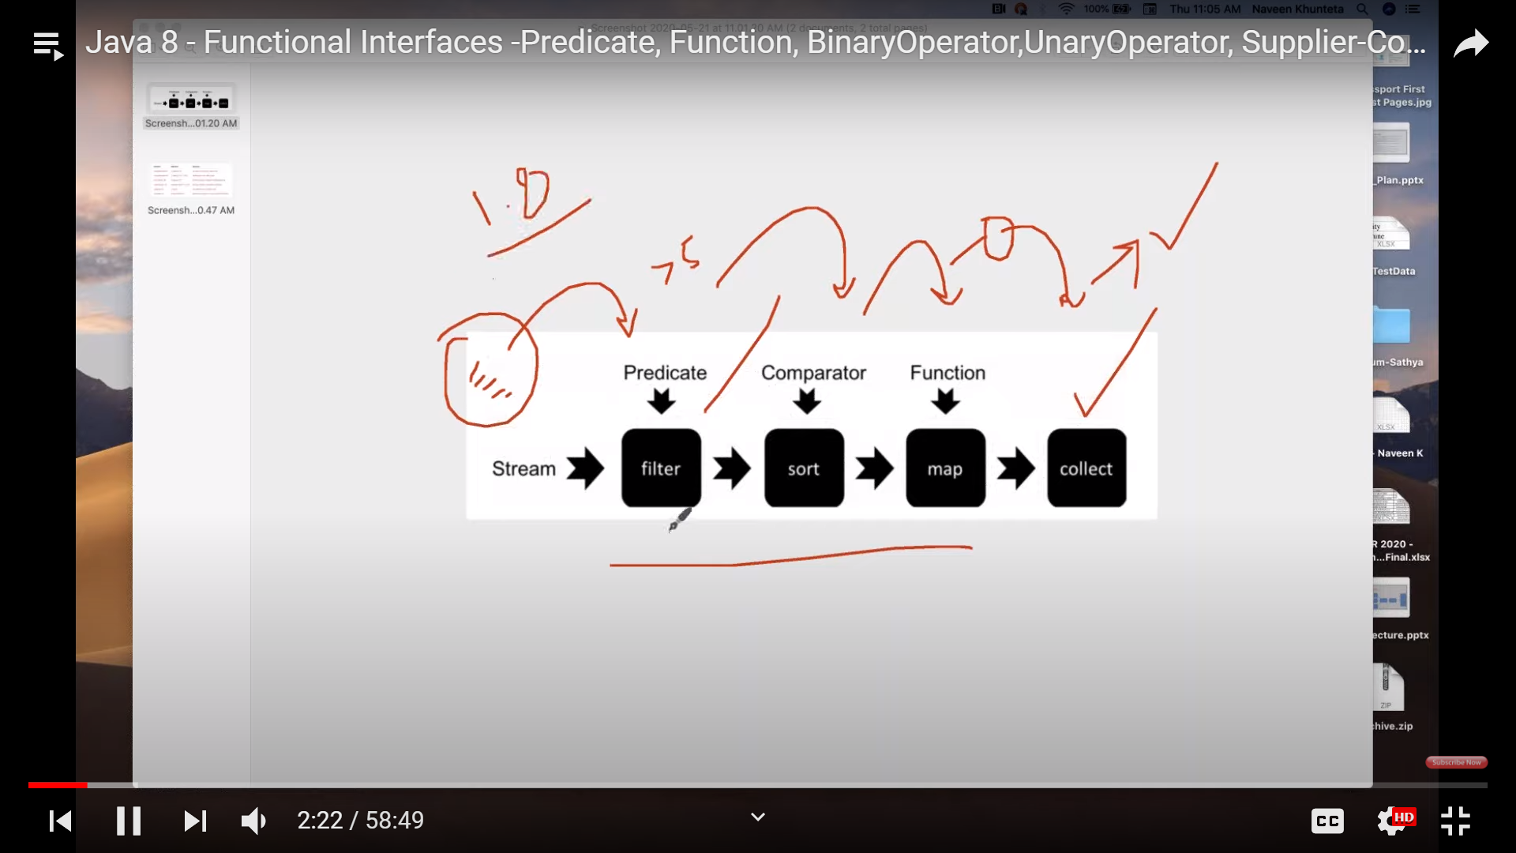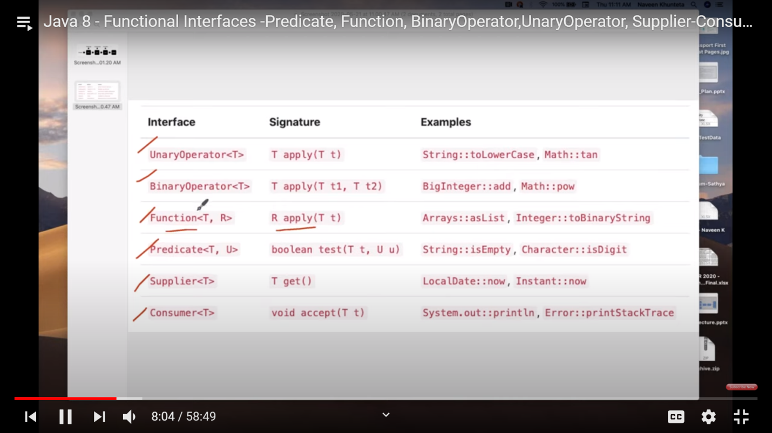

Link: https://devdocs.io/openjdk~8/java

Collections:

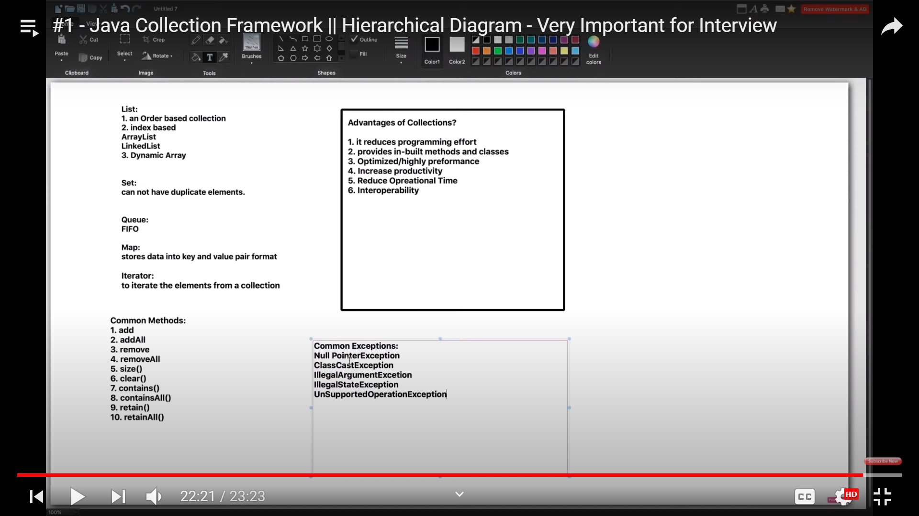

**HashMap working**

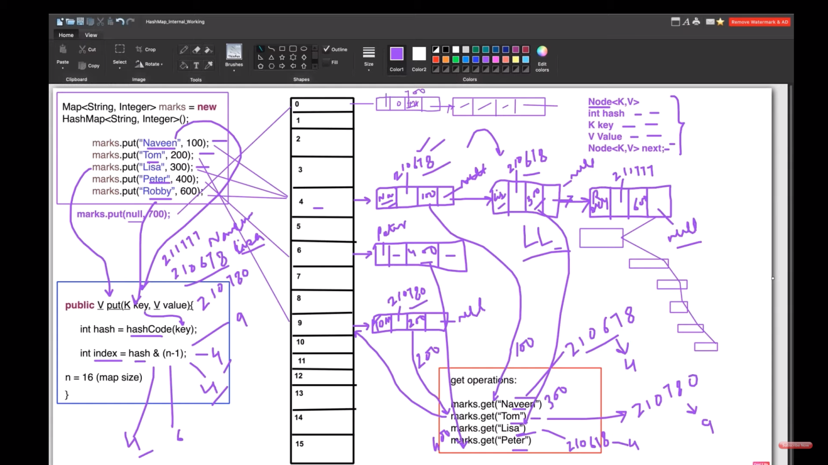

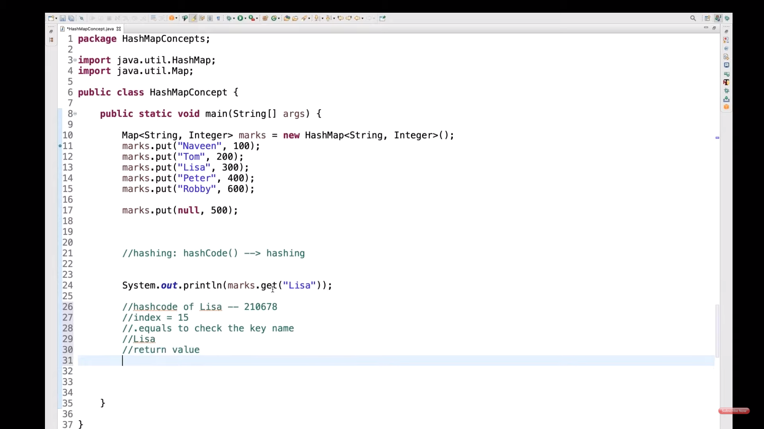

**HashMap Changes in Java 8**

As we know now that in case of hash collision entry objects are stored as a node in a[linked-list](https://www.geeksforgeeks.org/linked-list-set-1-introduction/) and equals() method is used to compare keys. That comparison to find the correct key with in a linked-list is a linear operation so in a worst case scenario the complexity becomes O(n).  
To address this issue, Java 8 hash elements use balanced trees instead of linked lists after a certain threshold is reached. Which means HashMap starts with storing Entry objects in linked list but after the number of items in a hash becomes larger than a certain threshold, the hash will change from using a linked list to a balanced tree, which will improve the worst case performance from O(n) to O(log n).

**Important Points**

* 1. Time complexity is almost constant for put and get method until rehashing is not done.
  2. In case of collision, i.e. index of two or more nodes are same, nodes are joined by link list i.e. second node is referenced by first node and third by second and so on.
  3. If key given already exist in HashMap, the value is replaced with new value.
  4. hash code of null key is 0.
  5. When getting an object with its key, the linked list is traversed until the key matches or null is found on next field.

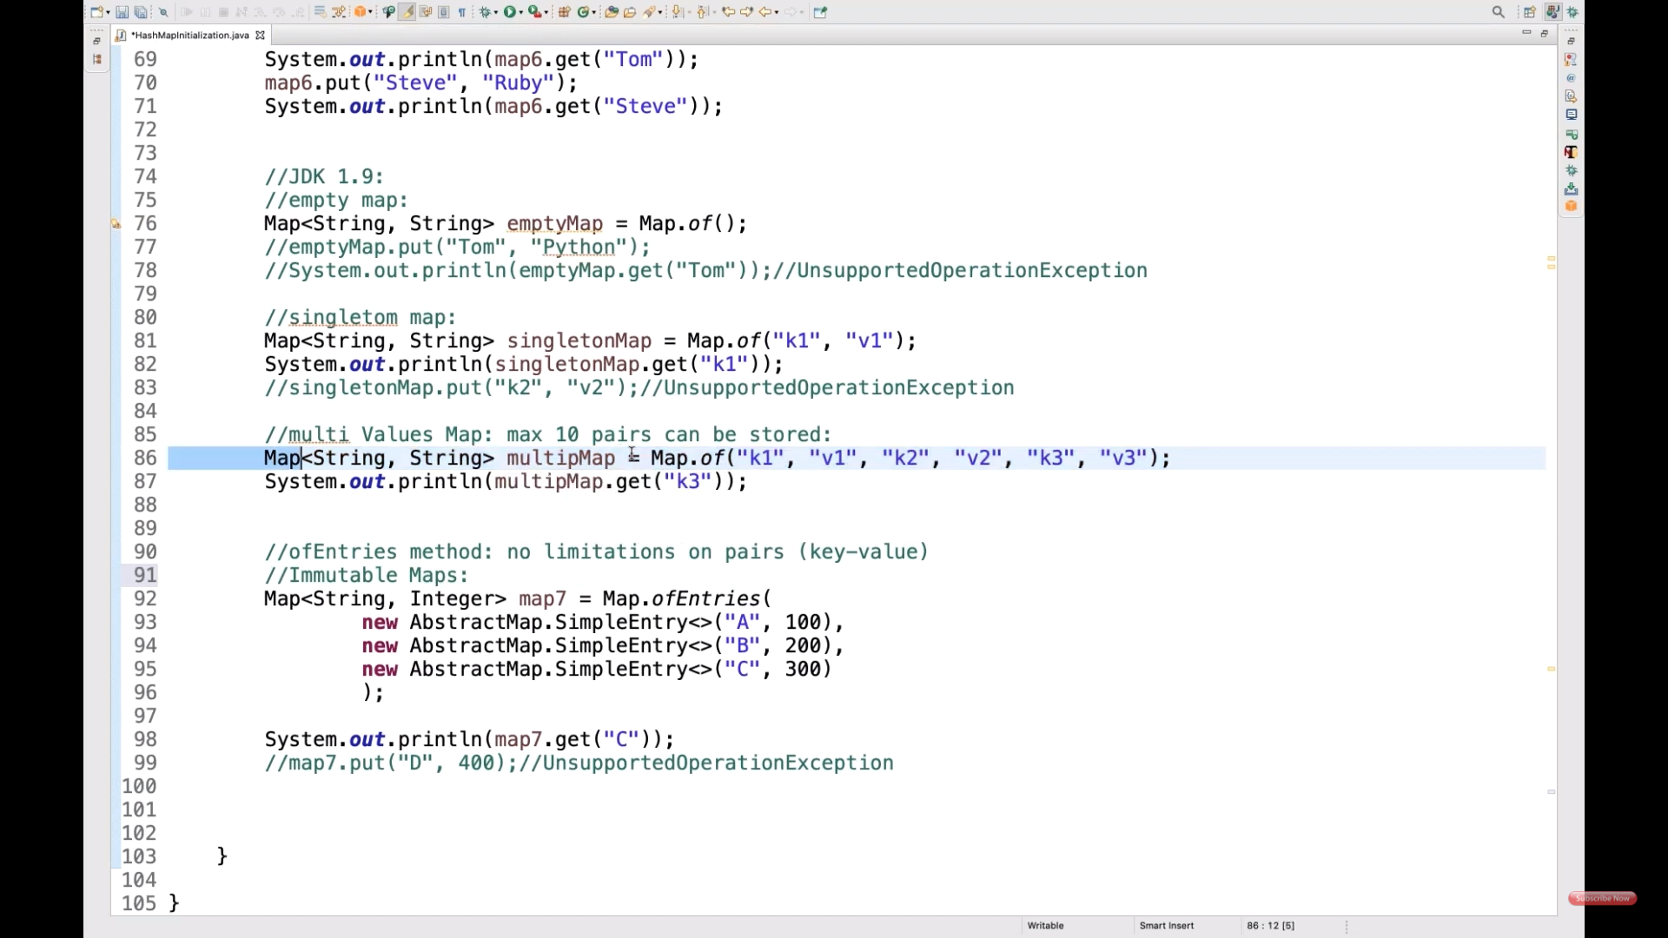

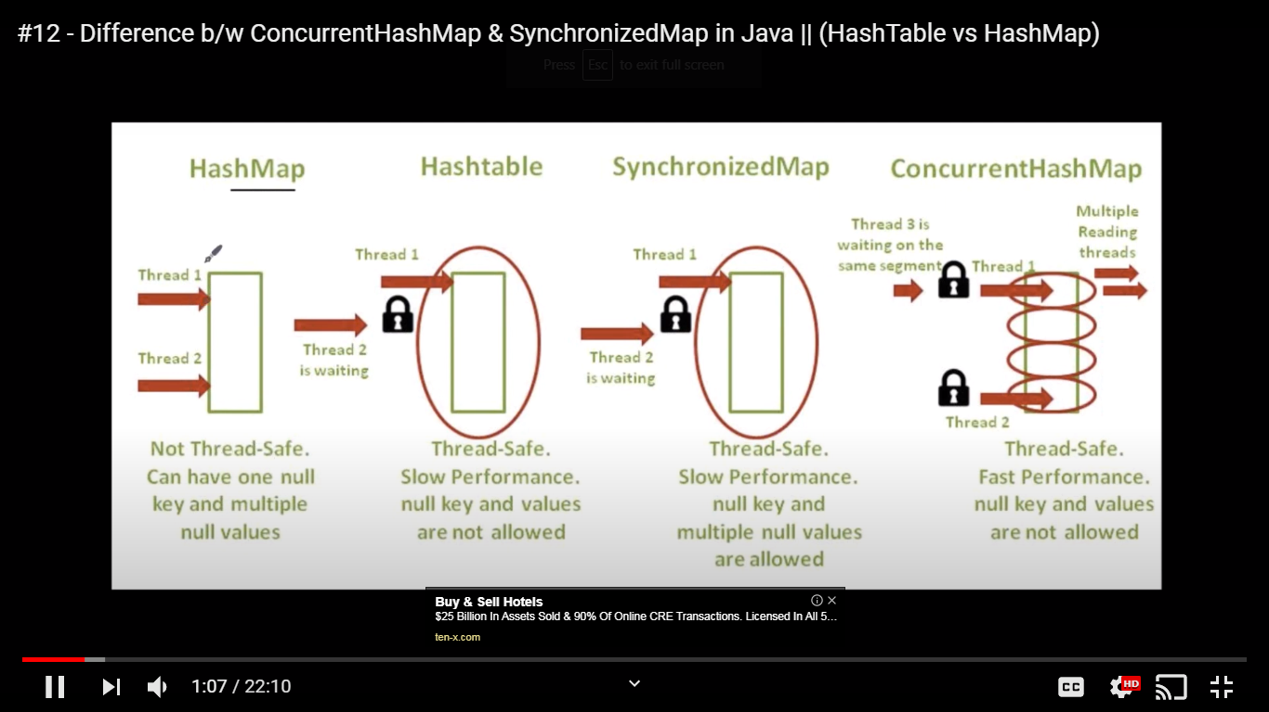

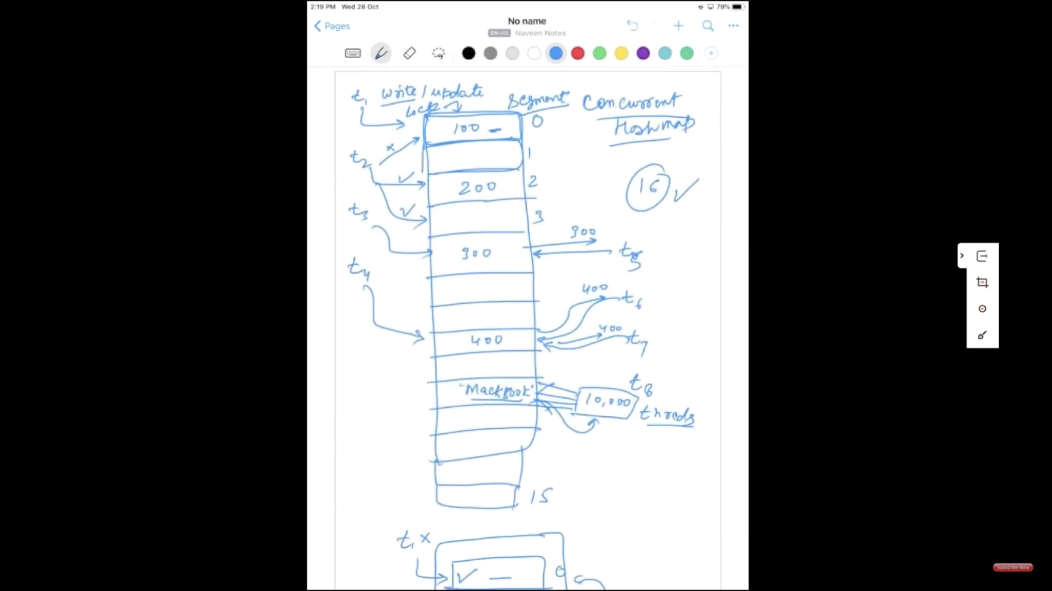

**Questions of Concurrent HashMap:**

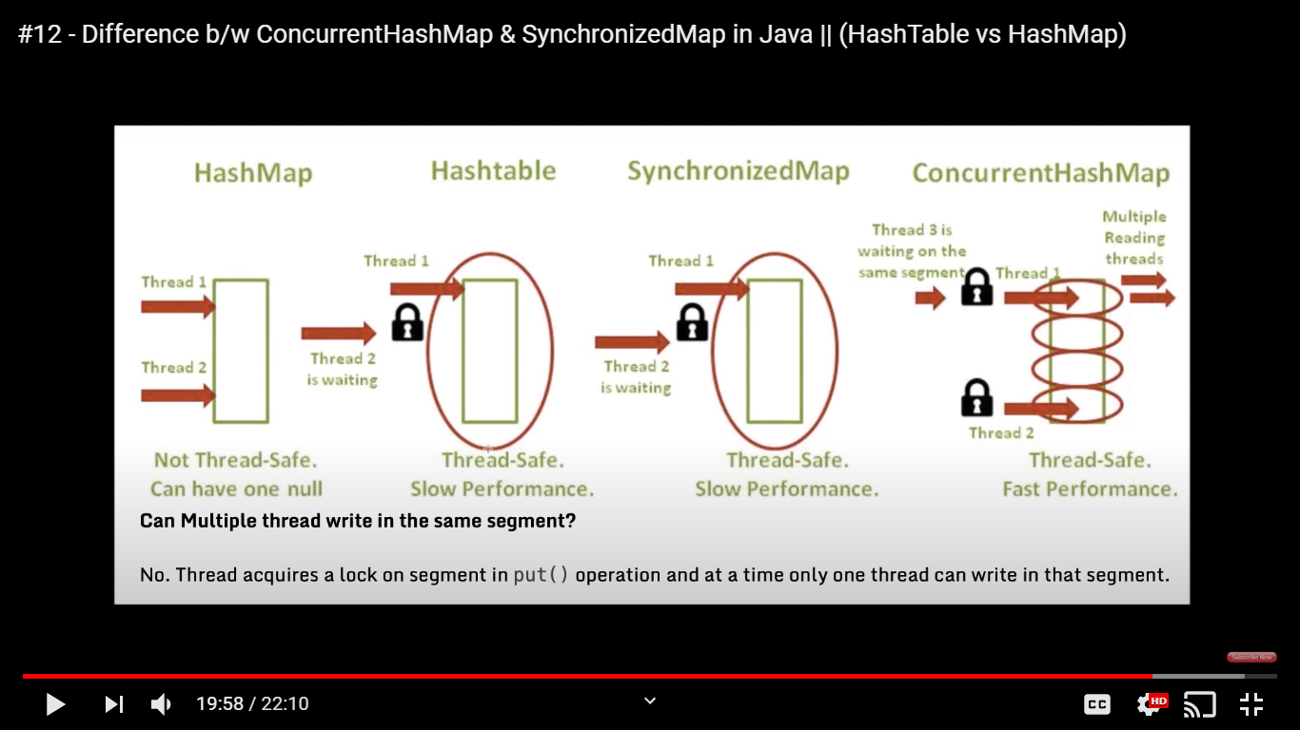

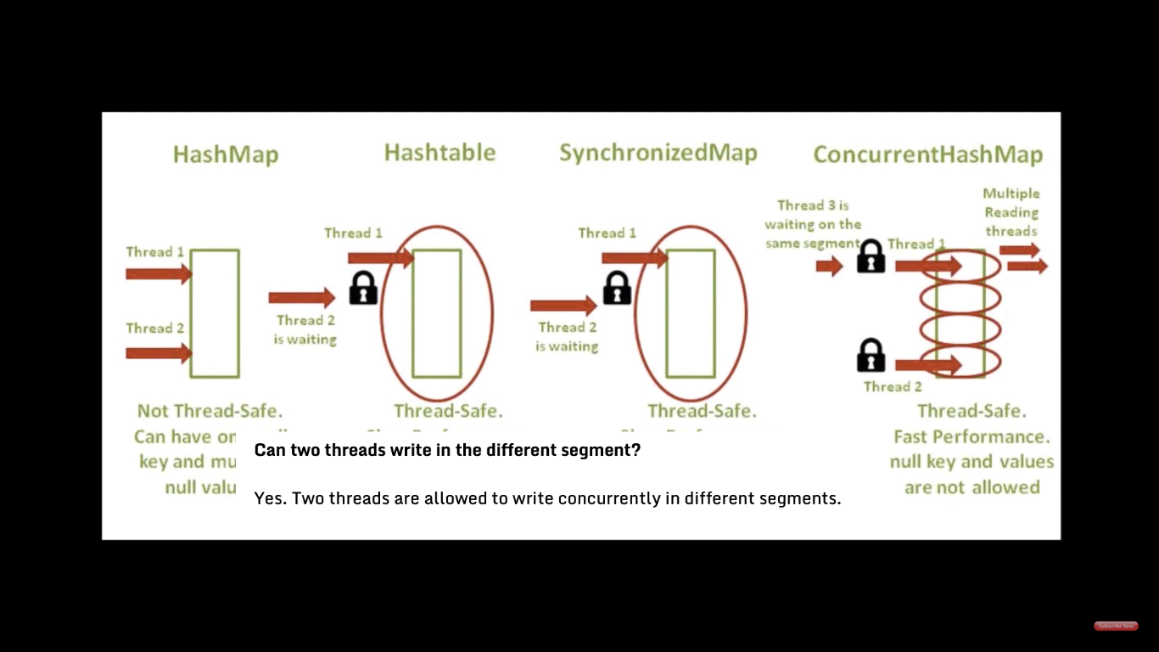

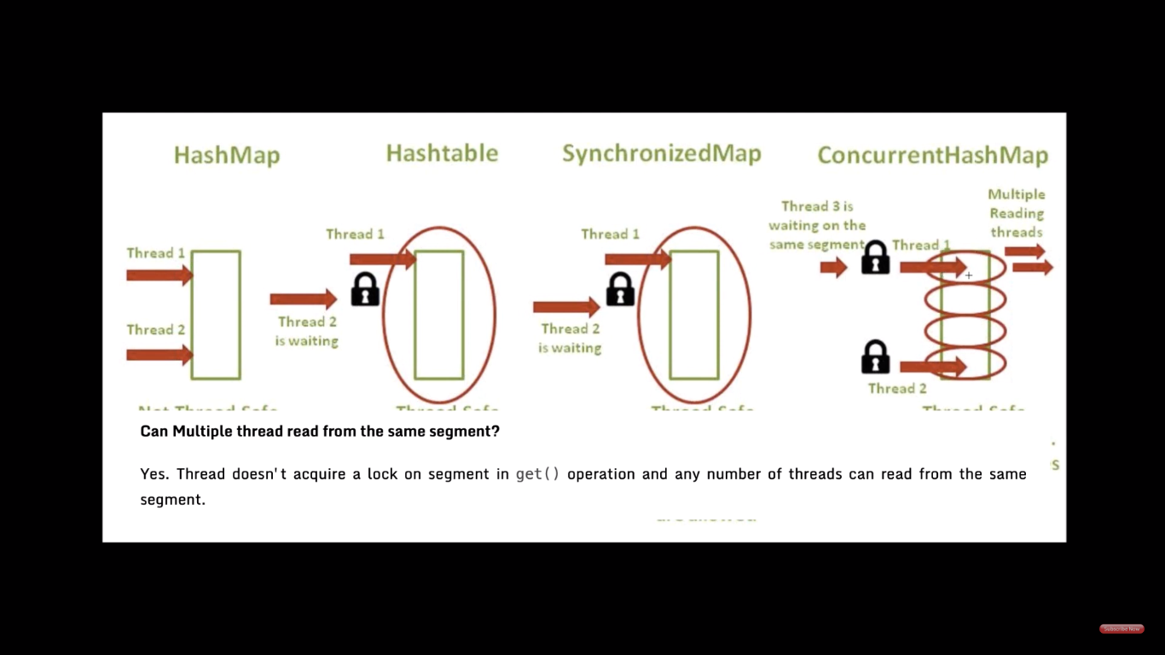

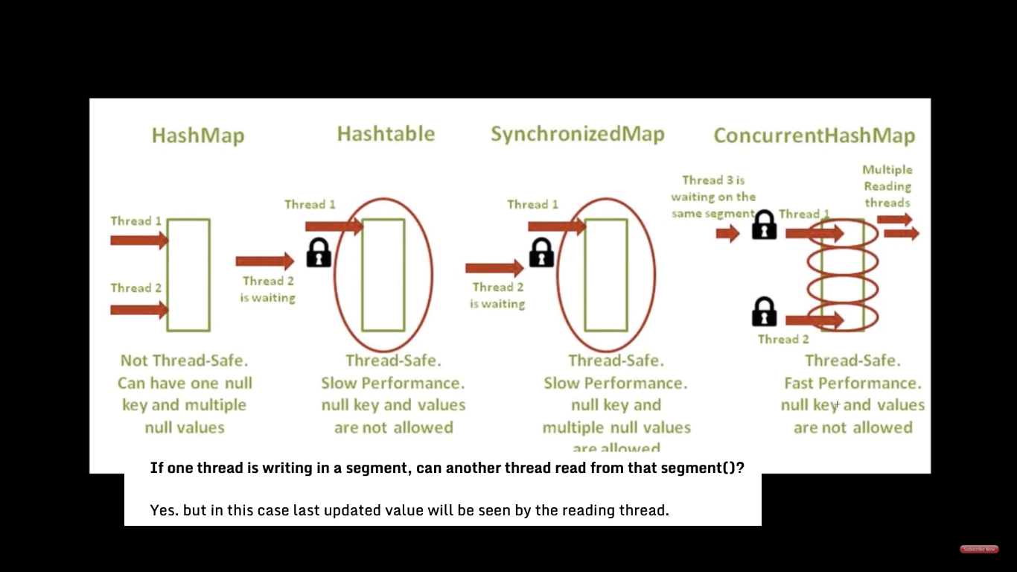

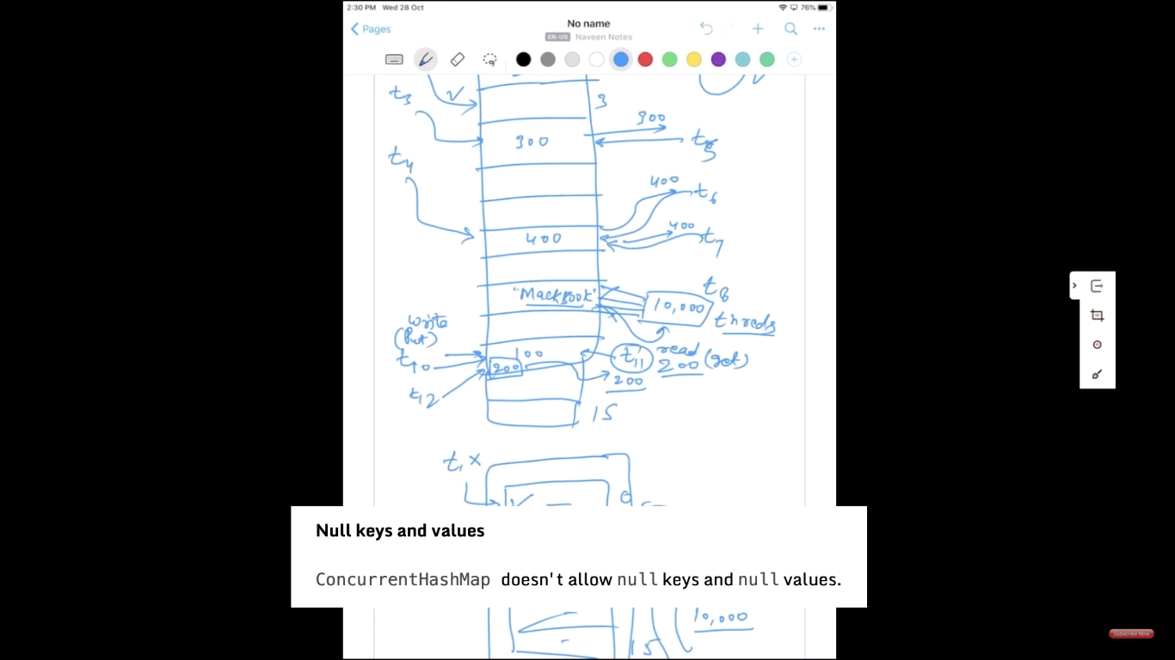

LinkedHashMap:

**Important Features of a LinkedHashMap:**

* A LinkedHashMap contains values based on the key. It implements the Map interface and extends the [HashMap](http://www.geeksforgeeks.org/java-util-hashmap-in-java/) class.
* It contains only unique elements.
* It may have one null key and multiple null values.
* It is non-synchronized.
* It is the same as HashMap with an additional feature that it maintains insertion order. For example, when we run the code with a HashMap, we get a different order of elements

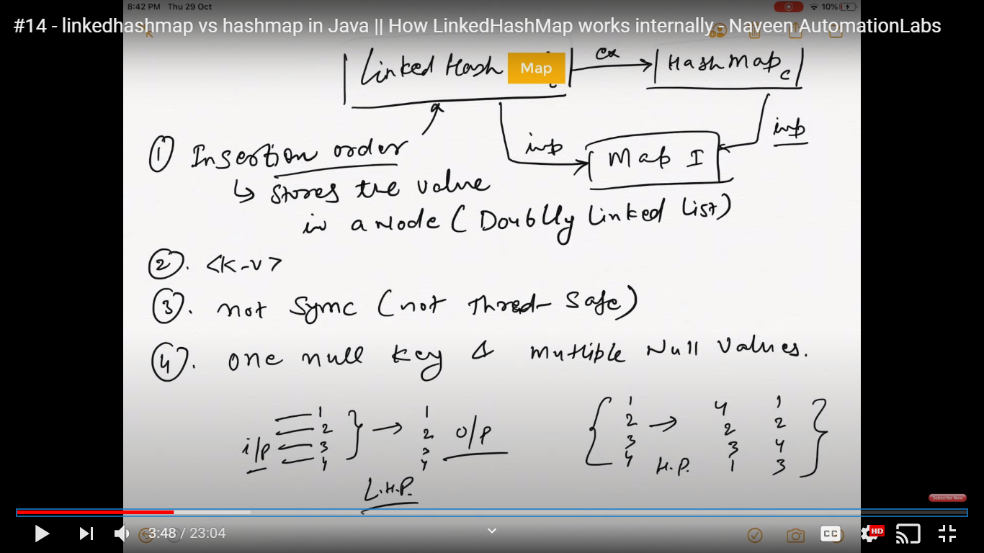

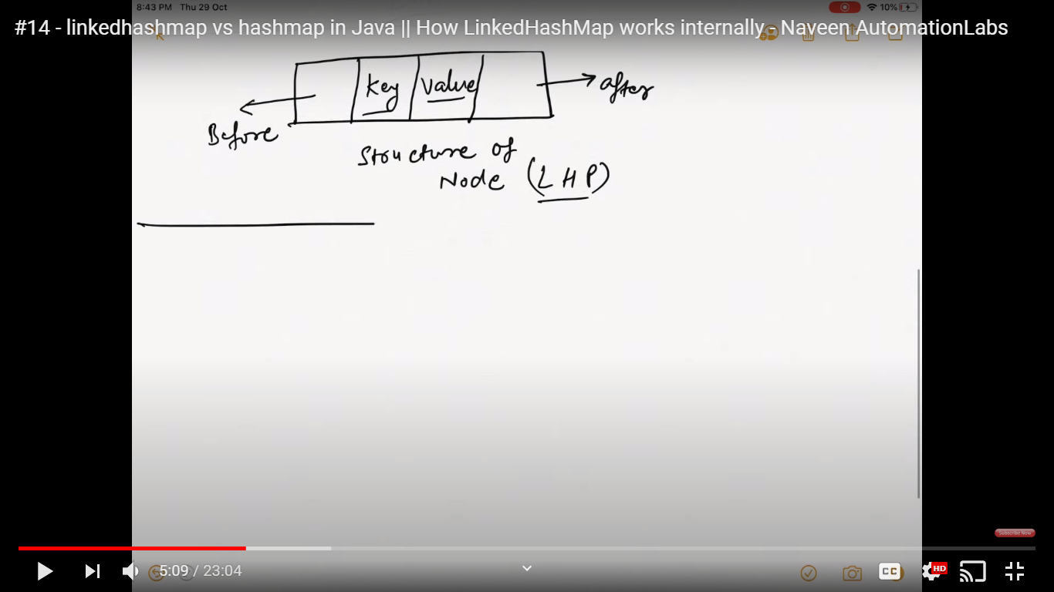

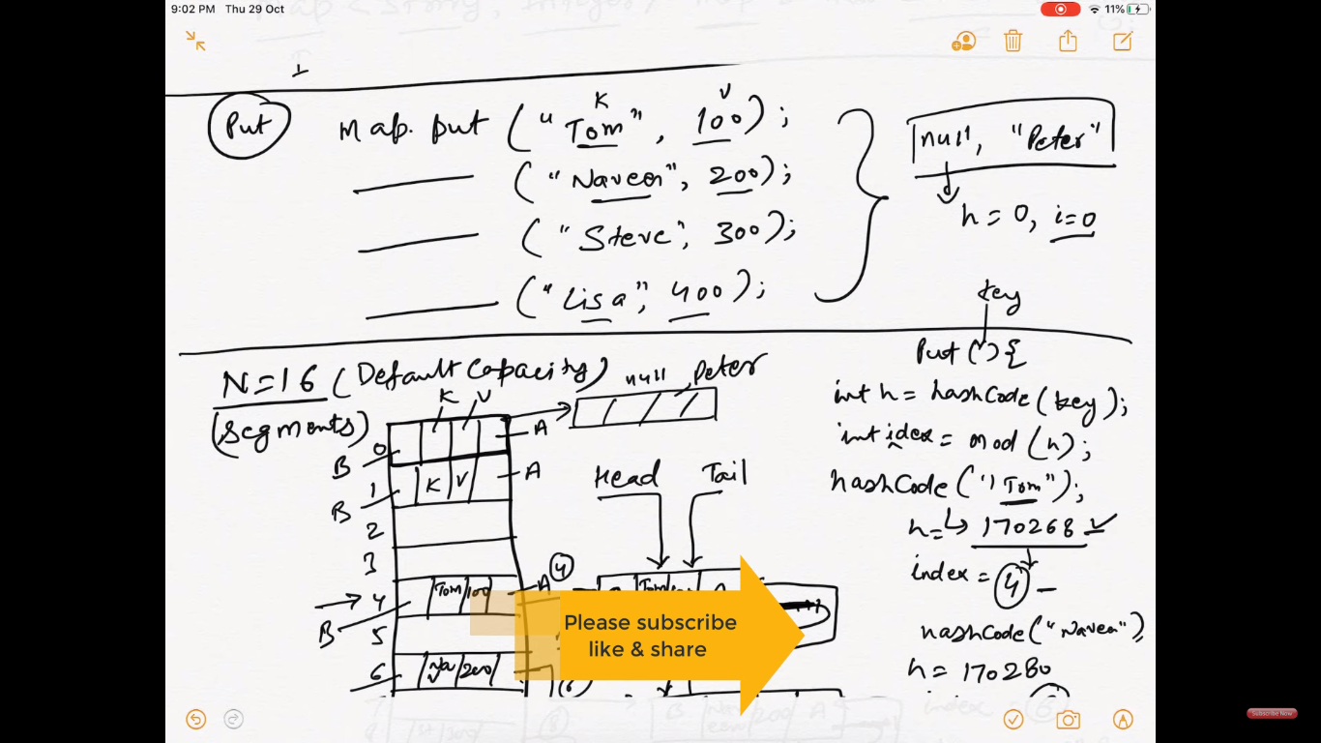

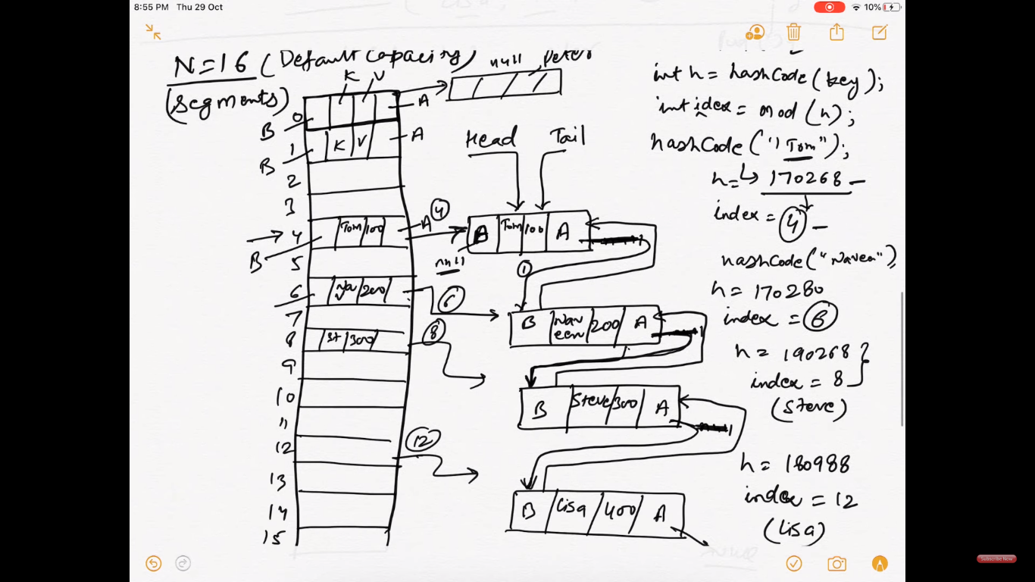

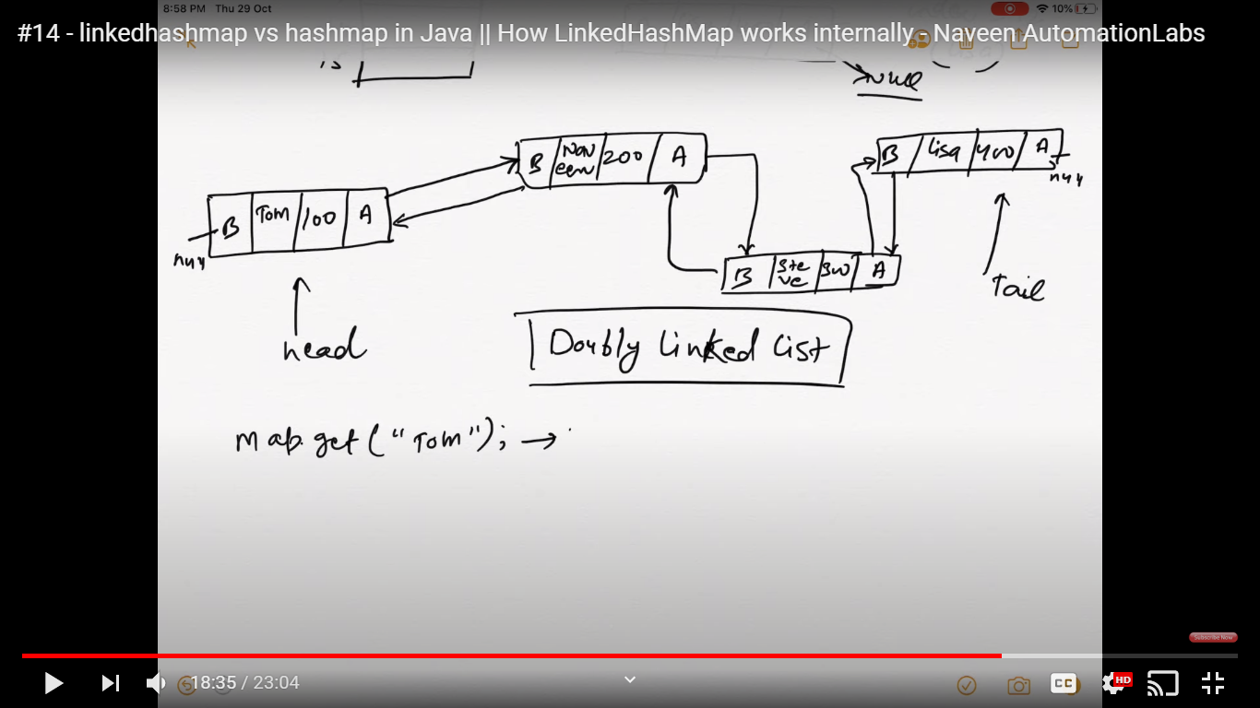

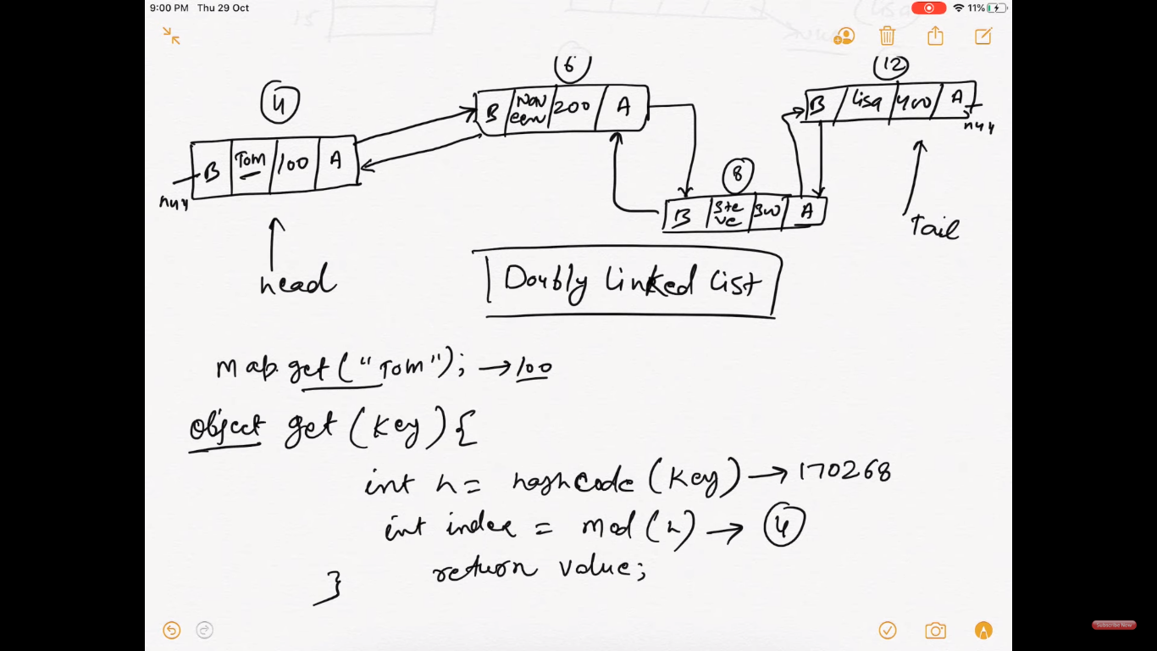

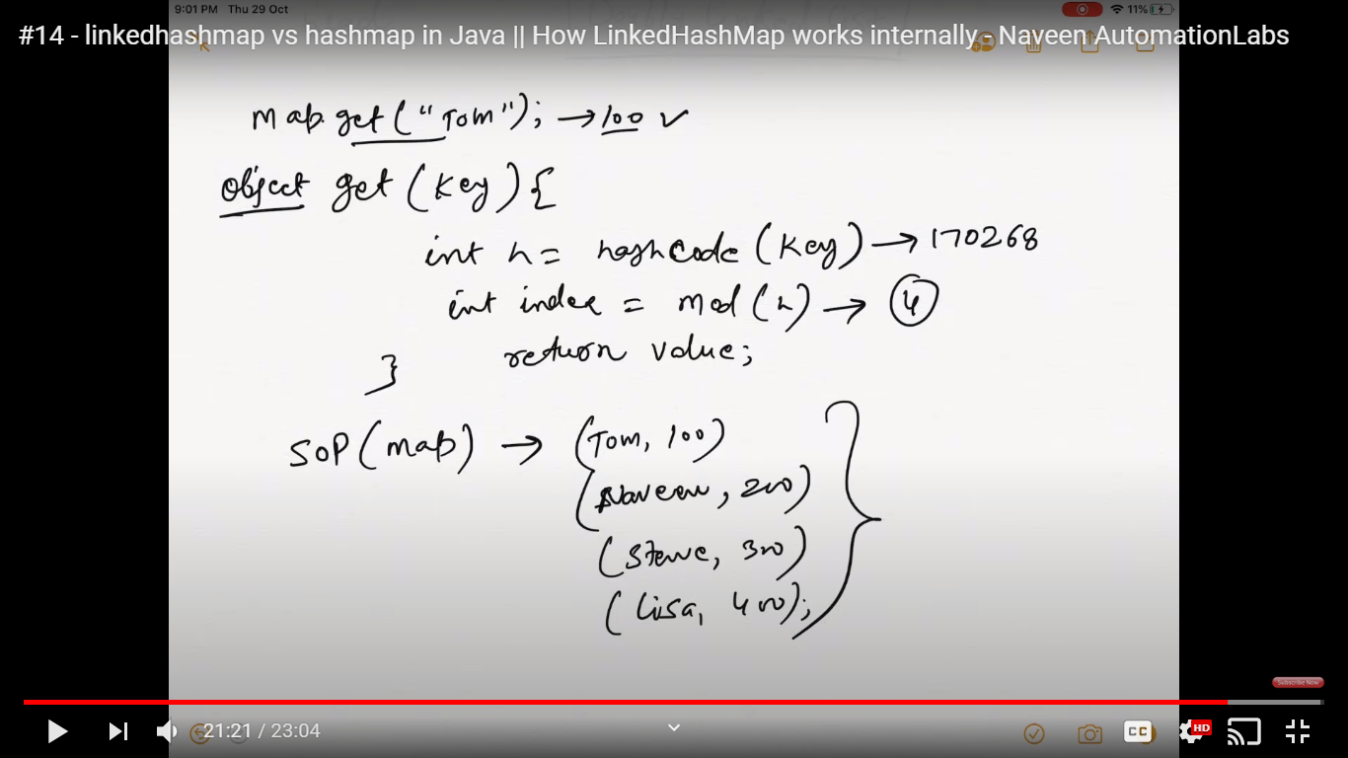

**Java HashMap Interview Questions:**

1. How does put() method of HashMap works in Java?

Ans: On hashing principle and its default virtual capacity is 16.

2. What is the requirement for an object to be used as key or value in HashMap?

Ans: both key and value should implement hashCode() and .equals() method.

3. What will happen if you try to store a key which is already present in HashMap?

Ans:It will return lastest value of the existing key. Yes, it is allowed.

4. Can you store a null key in Java HashMap?

Ans:Yes, only one null key is allowed.

5. Can you store a null value inside HashMap in Java?

Ans:yes,it allows multiple null values.

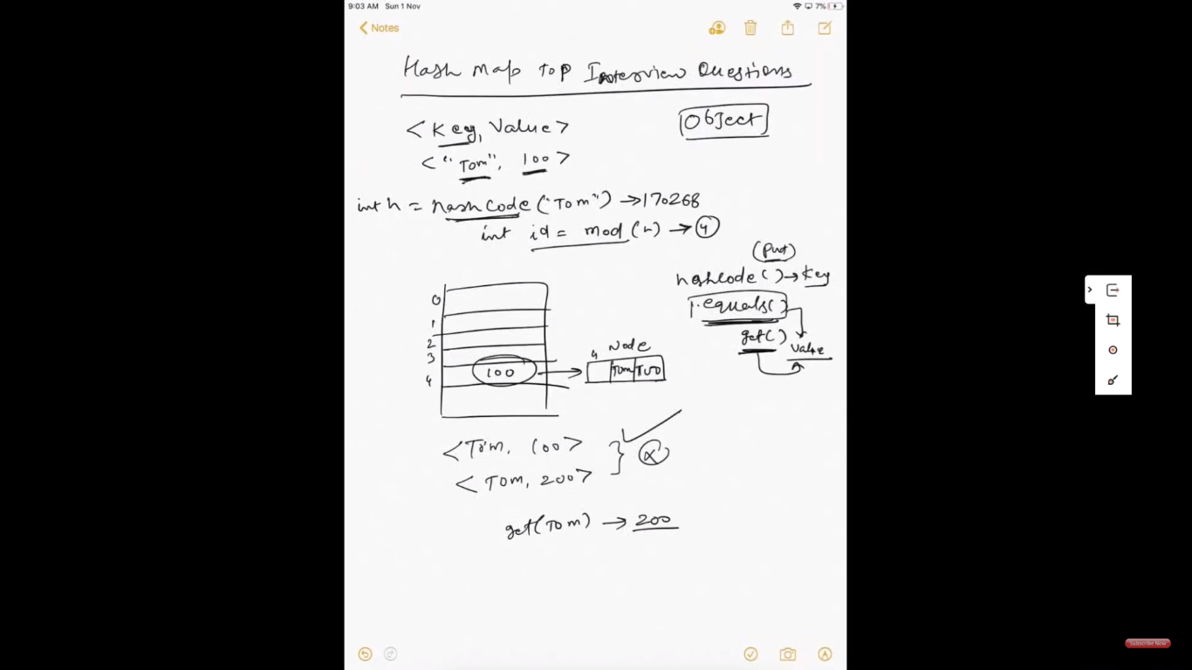

6. How does HashMap handle collisions in Java?

Ans: 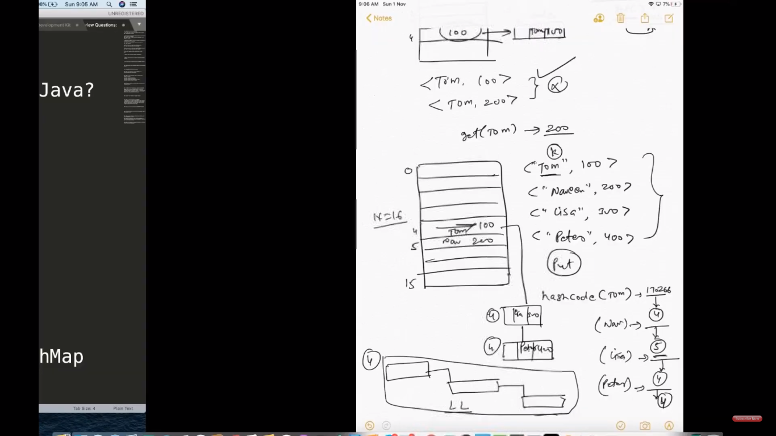

7. Which data structure HashMap represents?

Ans: Linked list and balanced binary tree

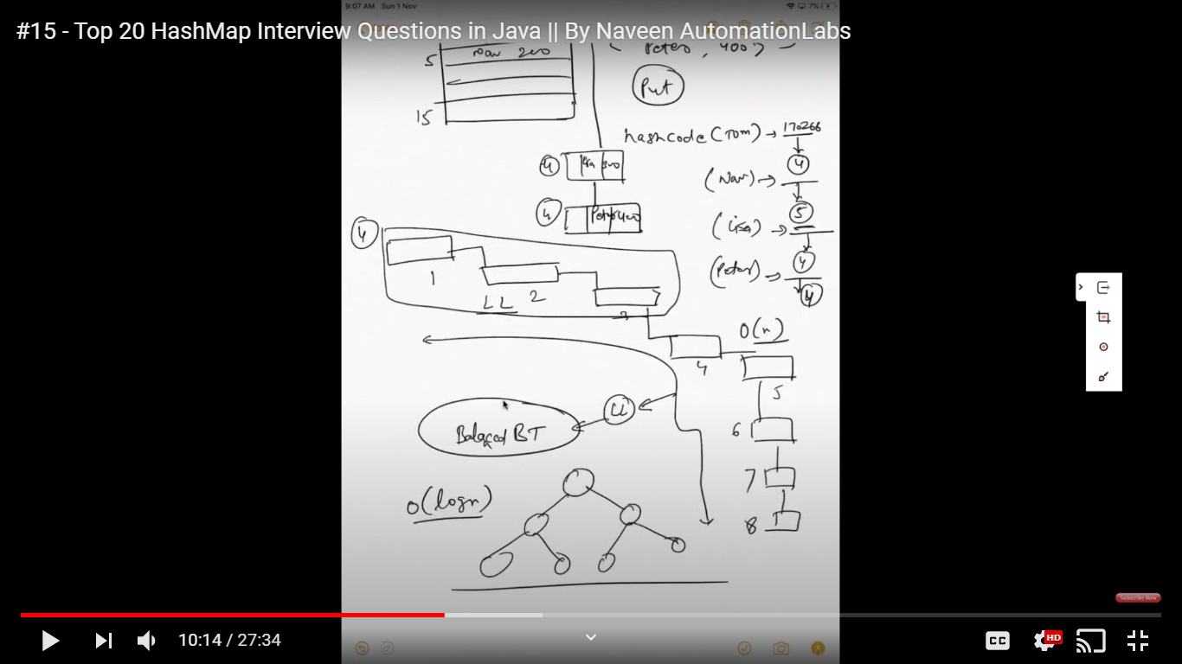

8. Which data structure is used to implement HashMap in Java?

Ans: same as 7

9. Can you store a duplicate key in HashMap? (answer)

Ans:No, we can’t.

10. Can you store the duplicate value in Java HashMap? (answer)

Ans:Yes, it is allowed

11. Is HashMap thread-safe in Java?

Ans,No. its not thread-safe or synchronized. We have to use synchronized hasmap or concurrent hash map.

12. What will happen if you use HashMap in a multithreaded Java application?

Ans:--not recommended. data might get corrupt.

--no use of this hashmap

13. What are the different ways to iterate over HashMap in Java?

1.by using keyset() and iterator

2. by using keyset() and values method

3. by using entrySet and iterator

4.by using entrySet() using for-each loop

5.by using forEach with lambda

14. How do you remove a mapping while iterating over HashMap in Java?

Ans: use remove method

15. In which order mappings are stored in HashMap?

Ans: Random order because HashMap doesn’t provide any ordering guarantee for keys, values or entries.

When you iterate over a hashmap you might get a different order everytime you iterate over it.

16. Can you sort HashMap in Java? (answer)

Ans: no you cann’t sort hashmap .

But you can convert this to LinkedHashMap or SortedMap which maintains the insertion order(sorting).

17. What is the load factor in HashMap?

Ans: A load factor is a number that controls the resizing of HashMap when a number of elements in the HashMap cross the load factor as if the load factor is 0.75 and when becoming more than 75% full then resizing trigger which involves array copy.

18. How does resizing happens in HashMap? (answer)

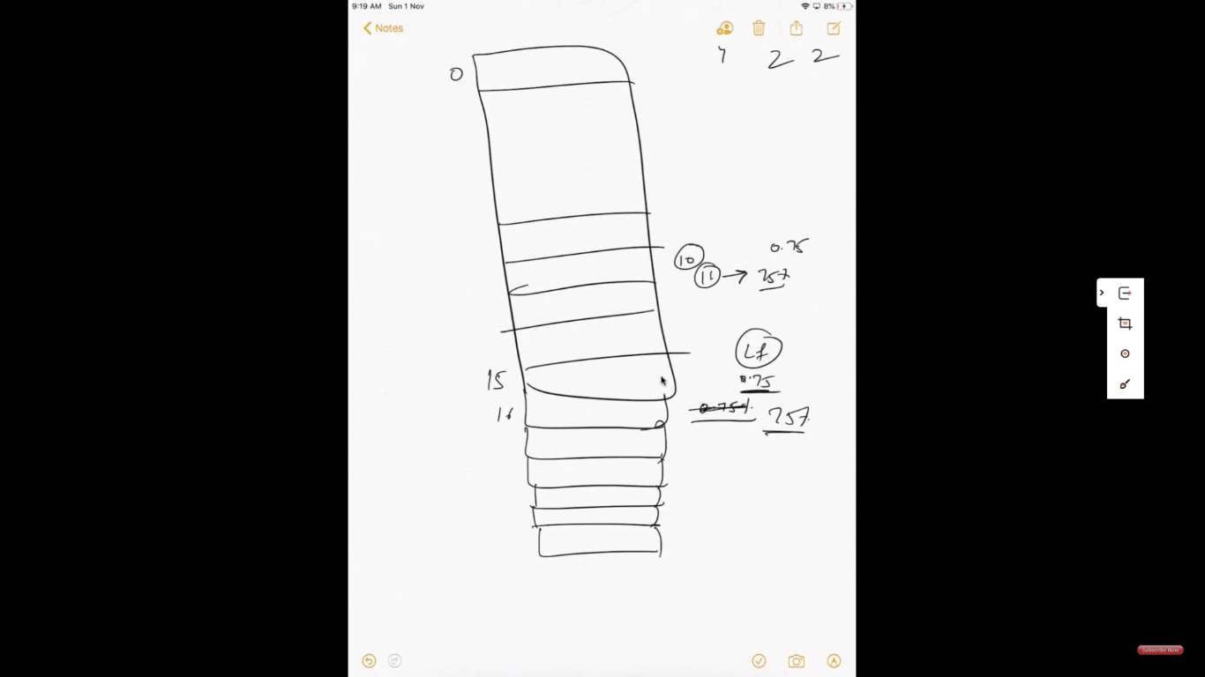

19. How many entries you can store in HashMap? What is the maximum limit?

Ans: no limit

20. What is the difference between the capacity and size of HashMap in Java?

Ans: The capacity denotes how many entries HashMap can store, and size denotes how many mappings or key/value pair is currently present.

21. What will happen if two different keys of HashMap return the same hashcode()?

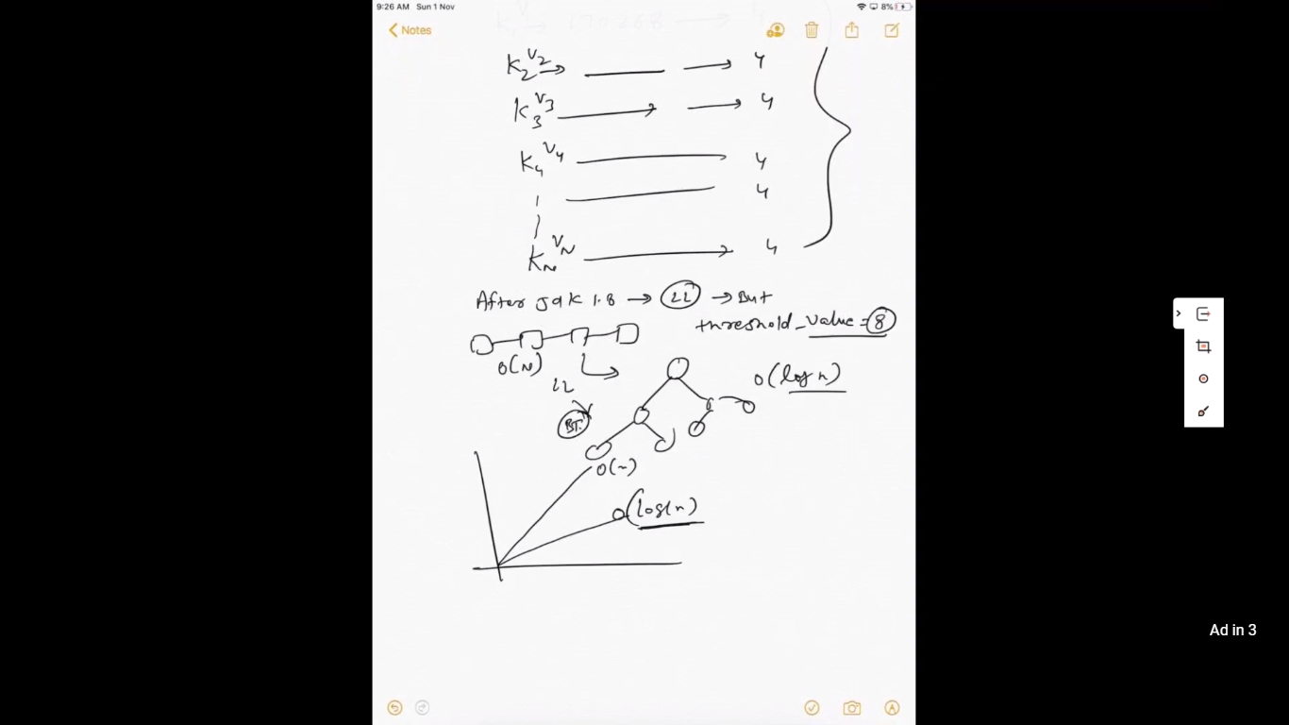

TreeMap:

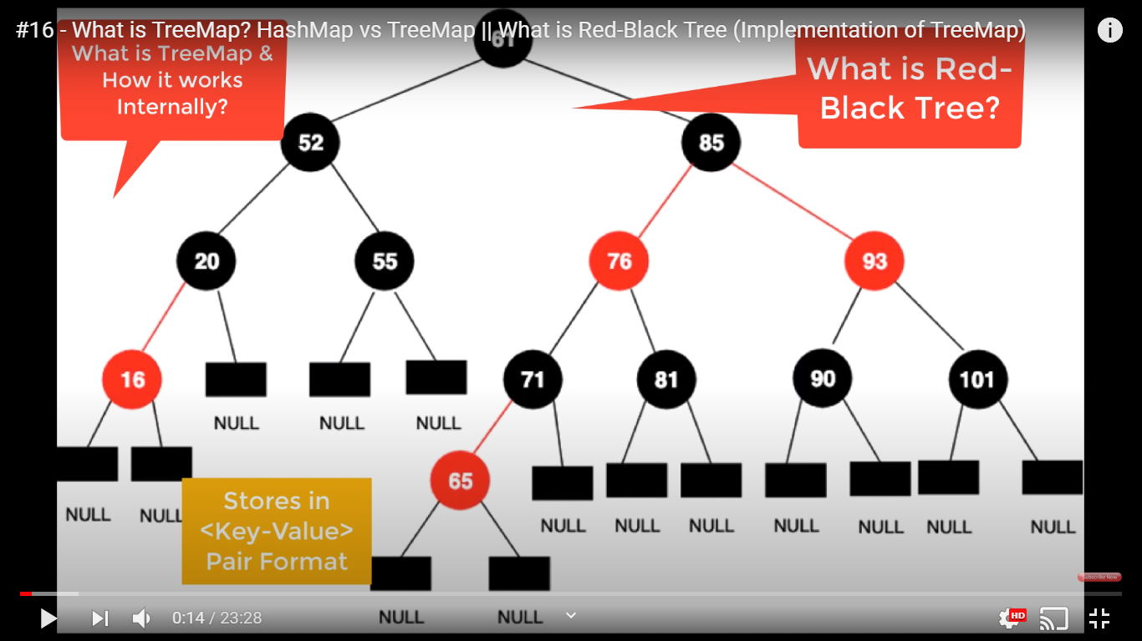

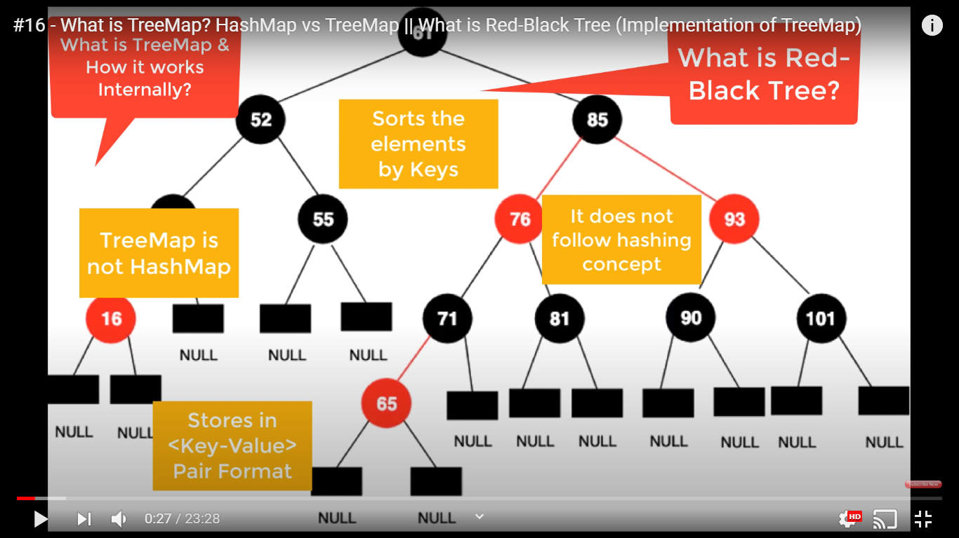

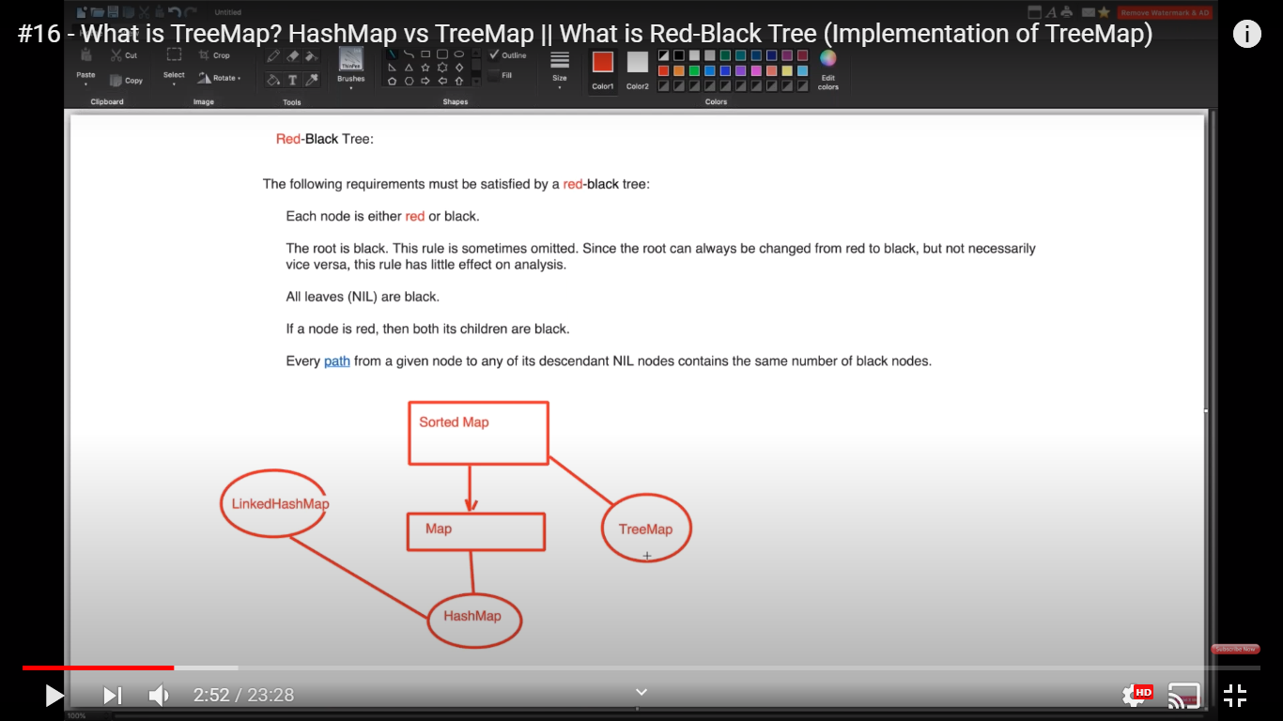

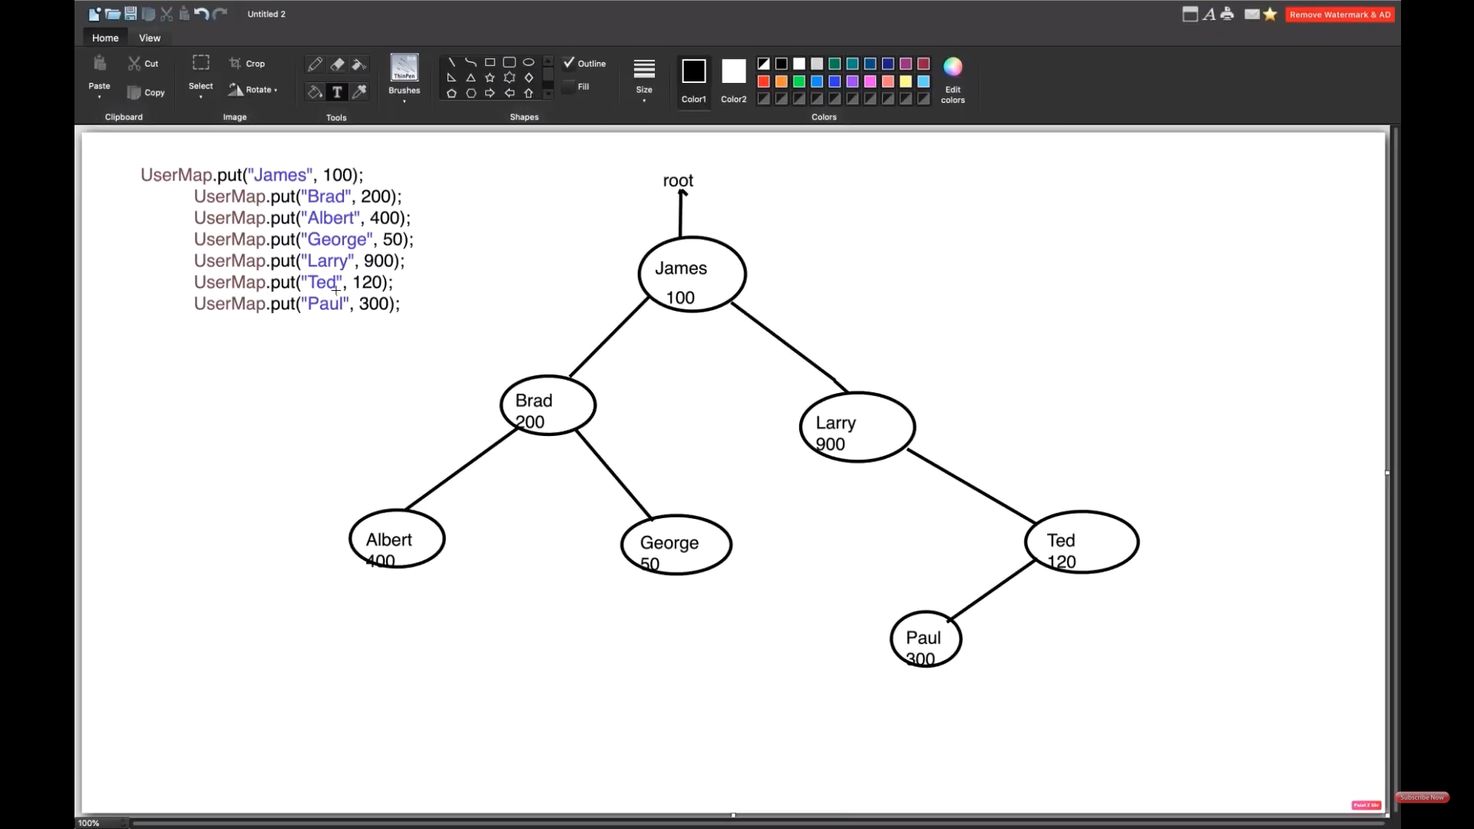

**Features of a TreeMap:**

Some important features of the treemap are:

1. This class is a member of [Java Collections](https://www.geeksforgeeks.org/collections-in-java-2/) Framework.
2. The class implements [Map interfaces](https://www.geeksforgeeks.org/map-interface-java-examples/) including [NavigableMap](https://www.geeksforgeeks.org/navigablemap-interface-in-java-with-example/), [SortedMap](https://www.geeksforgeeks.org/sortedmap-java-examples/) and extends AbstractMap class.
3. TreeMap in Java does not allow null keys (like Map) and thus a [NullPointerException](http://www.geeksforgeeks.org/null-pointer-exception-in-java/) is thrown. However, multiple null values can be associated with different keys.
4. Entry pairs returned by the methods in this class and its views represent snapshots of mappings at the time they were produced. They do not support the [Entry.setValue](https://www.geeksforgeeks.org/map-entry-interface-java-example/) method.

5.  A TreeMap is based upon a [redblack tree](https://www.geeksforgeeks.org/red-black-tree-set-1-introduction-2/) data structure. Each node in the tree has:

* 3 Variables (K key=Key, V value=Value, boolean color=Color)
* 3 References (Entry left = Left, Entry right = Right, Entry parent = Parent)

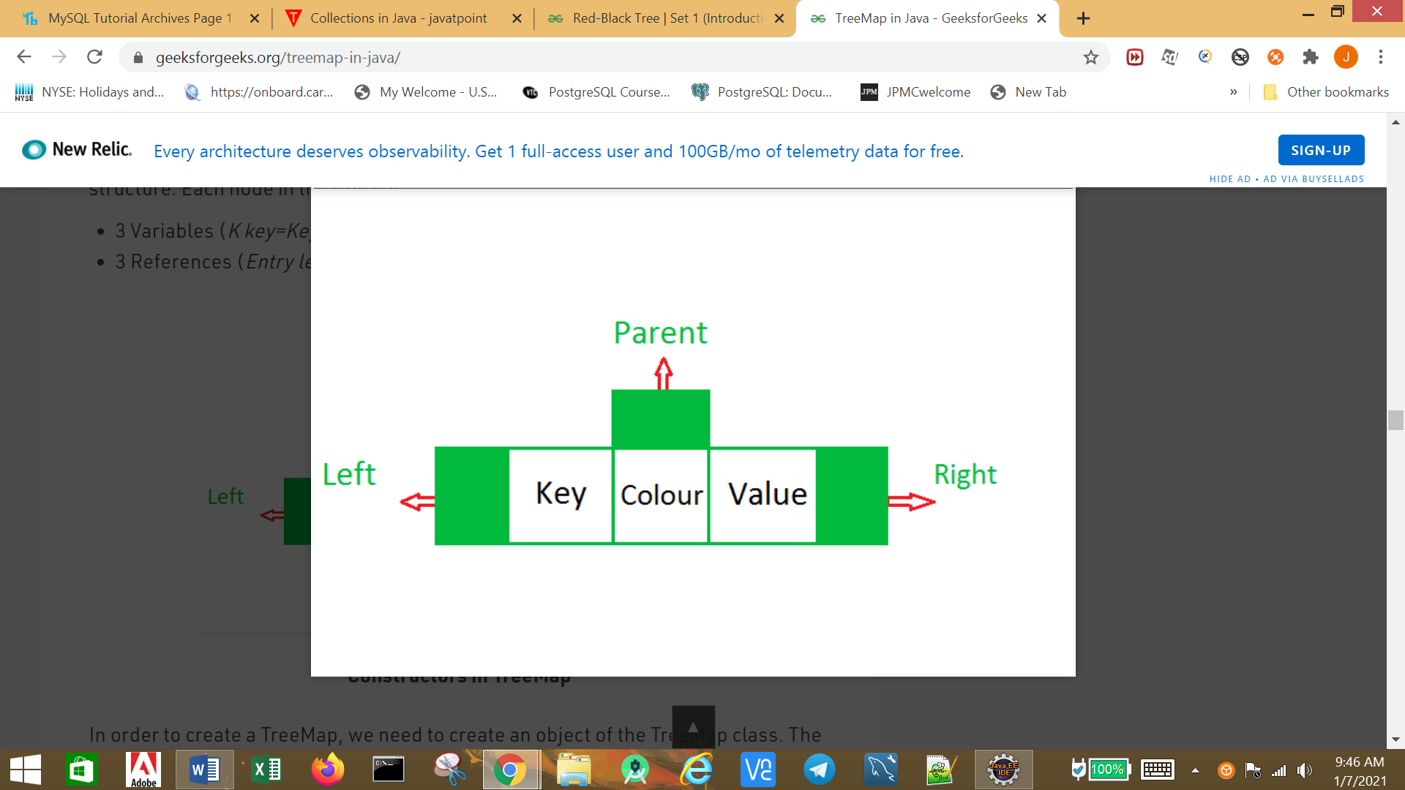

Synchronized TreeMap:

SortedMap<String, Integer> userMap2=Collections.*synchronizedSortedMap*(**new** TreeMap<>());

HashTable:

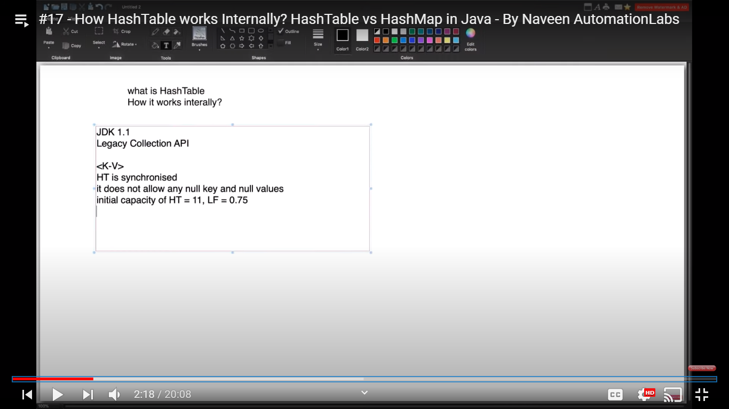

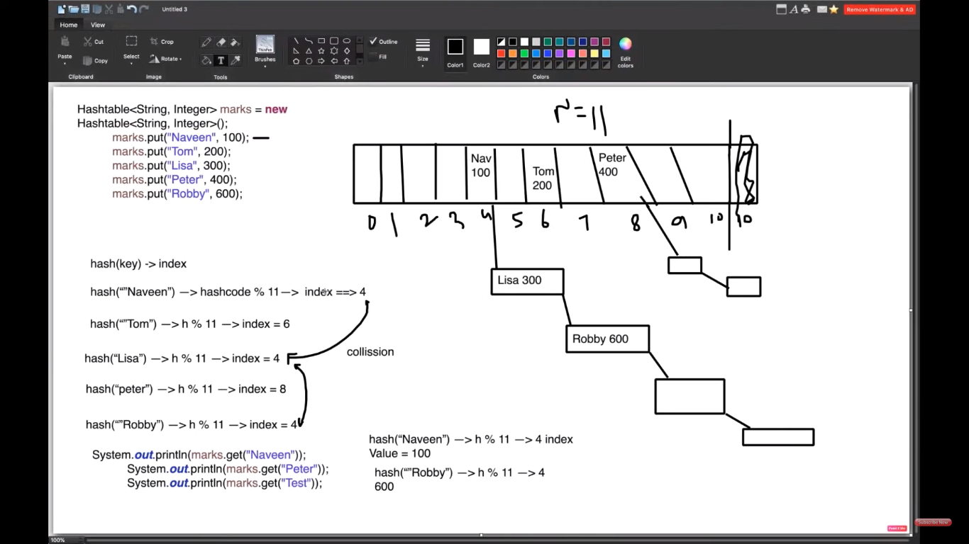

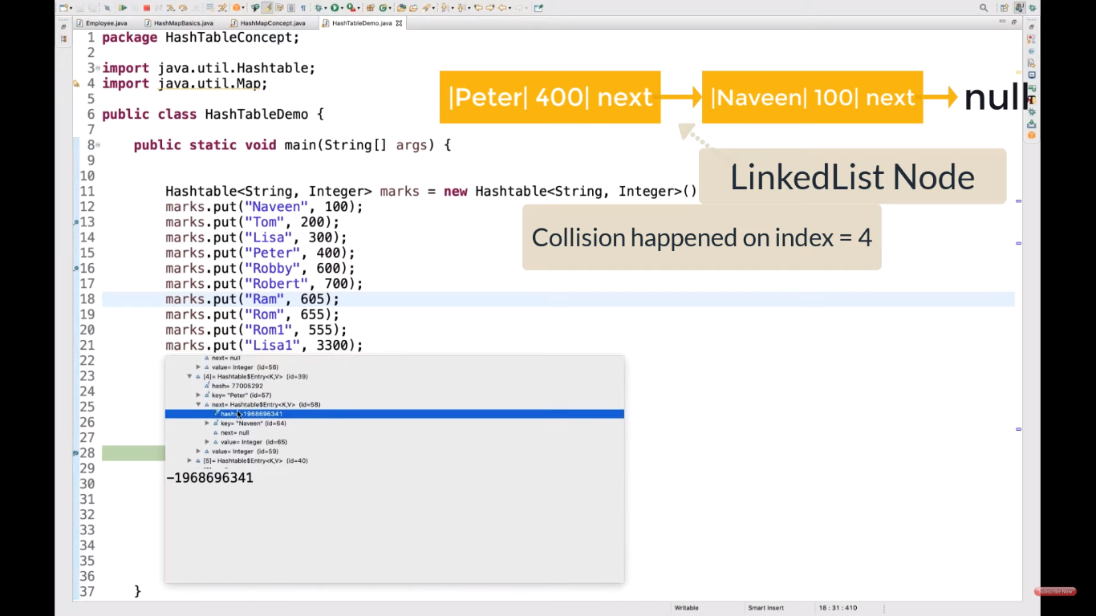

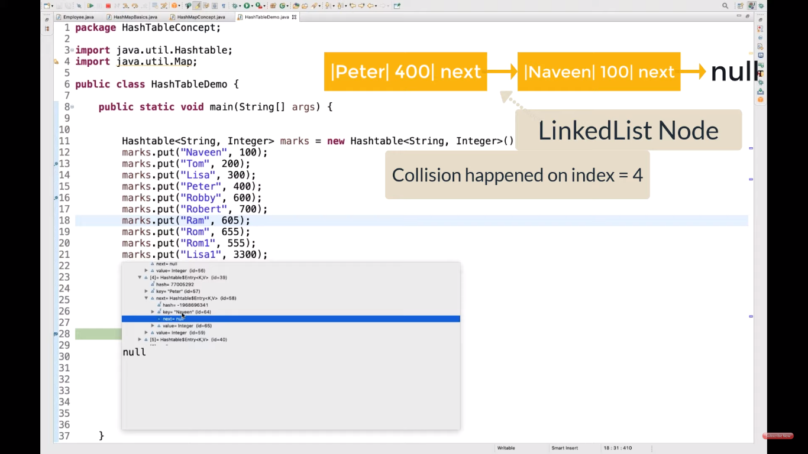

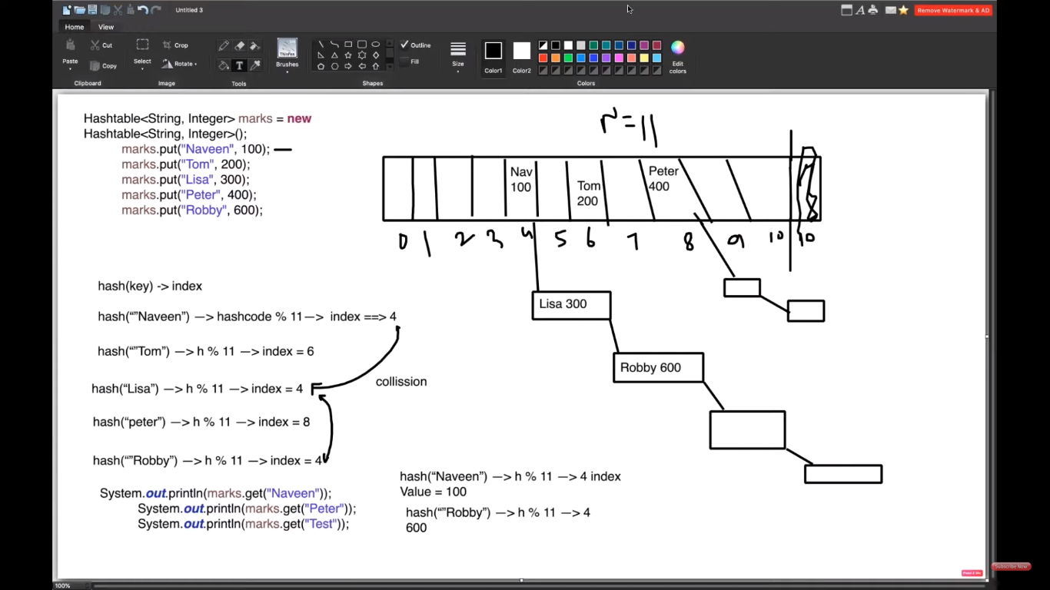

LinkedList

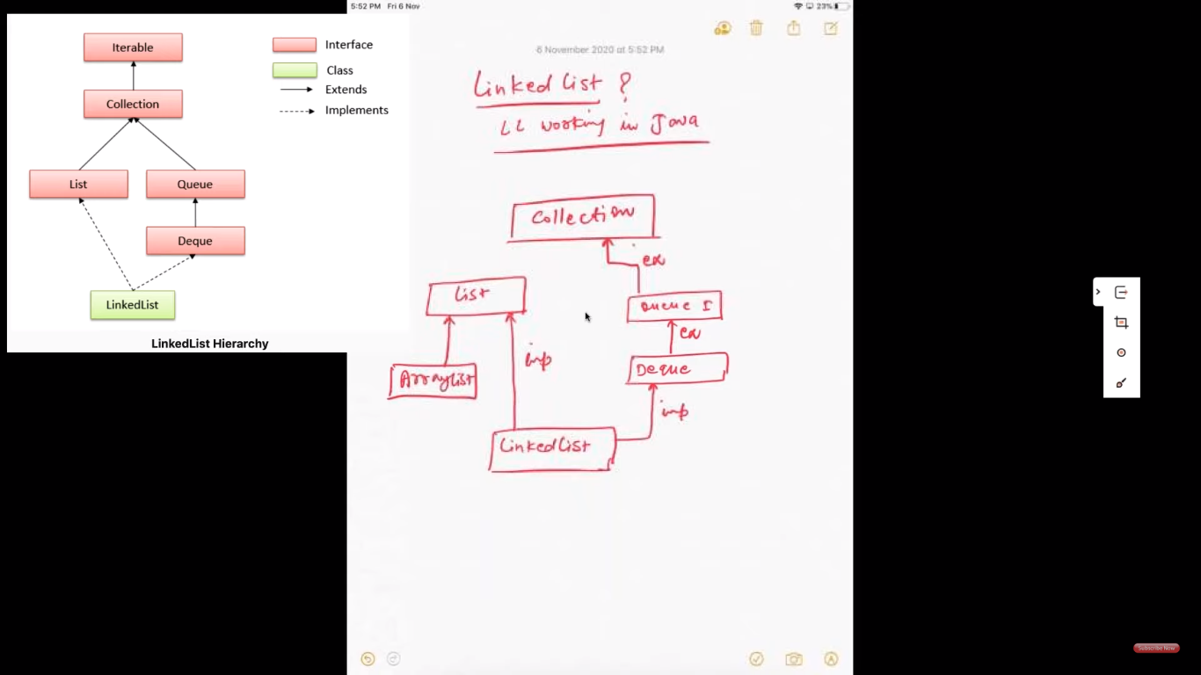

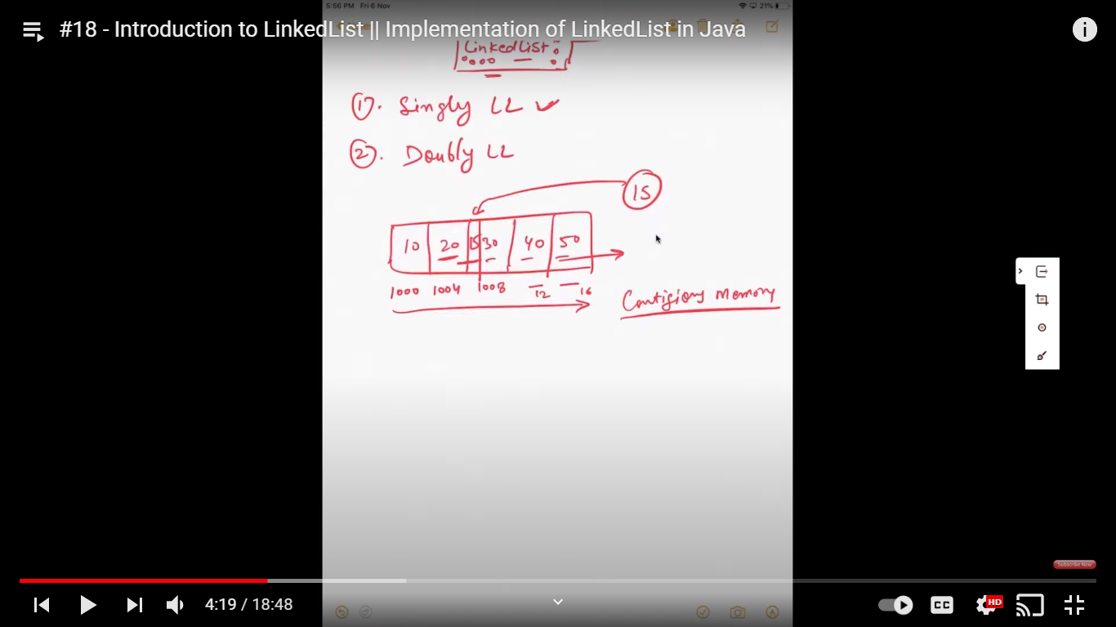

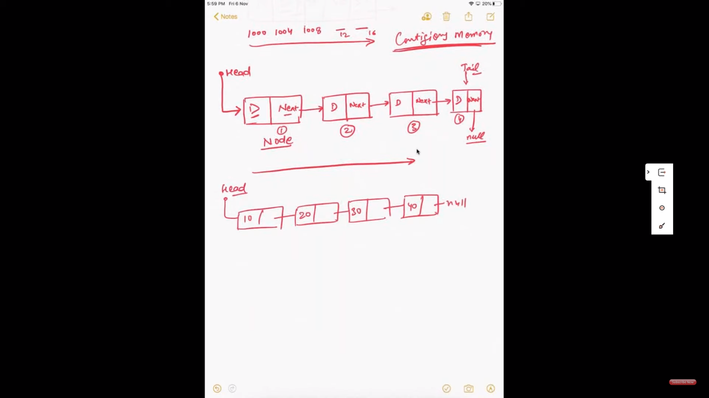

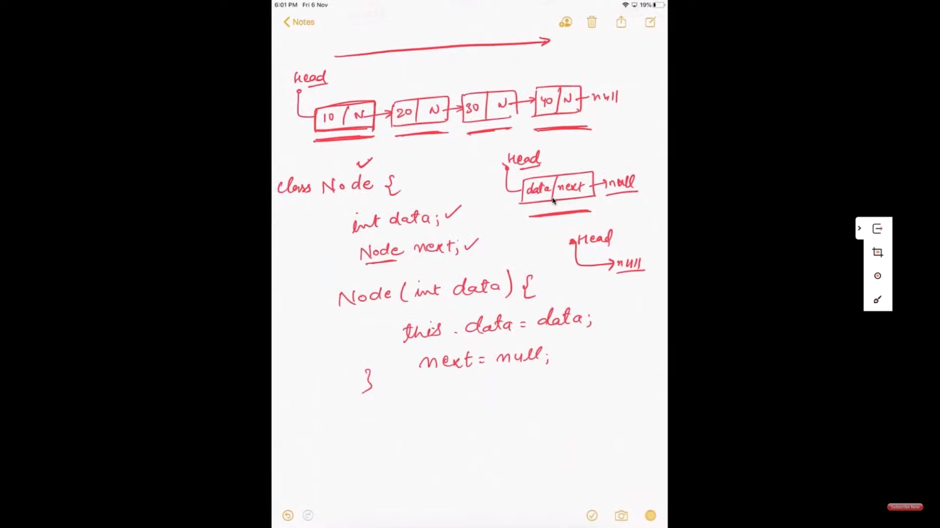

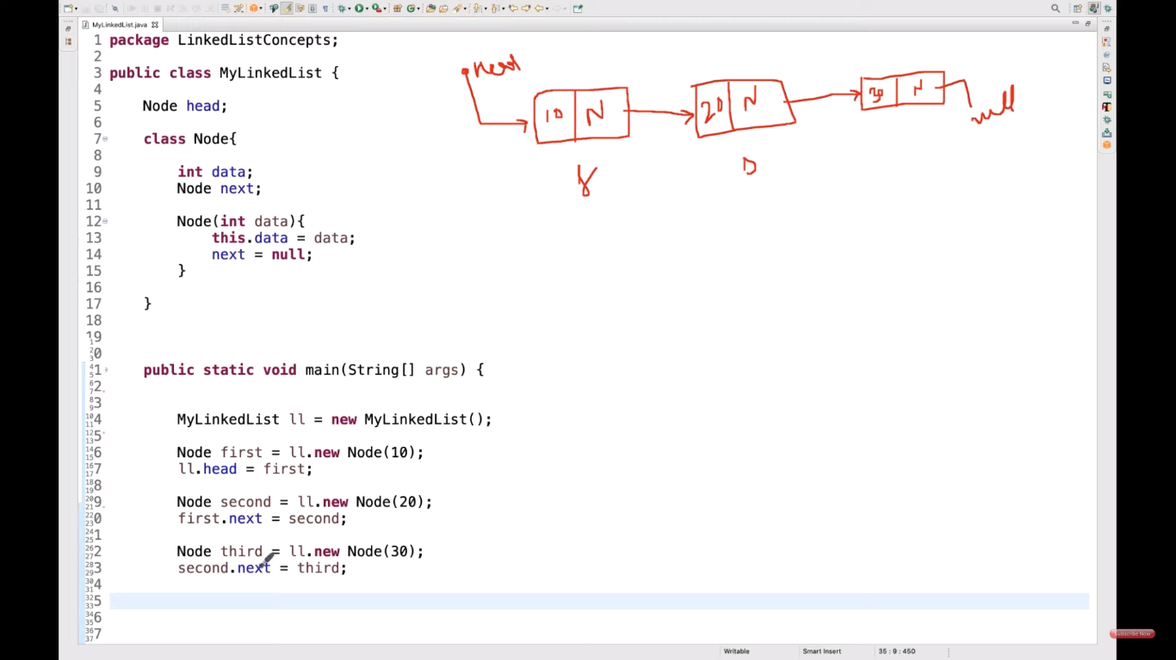

Linked List Methods:

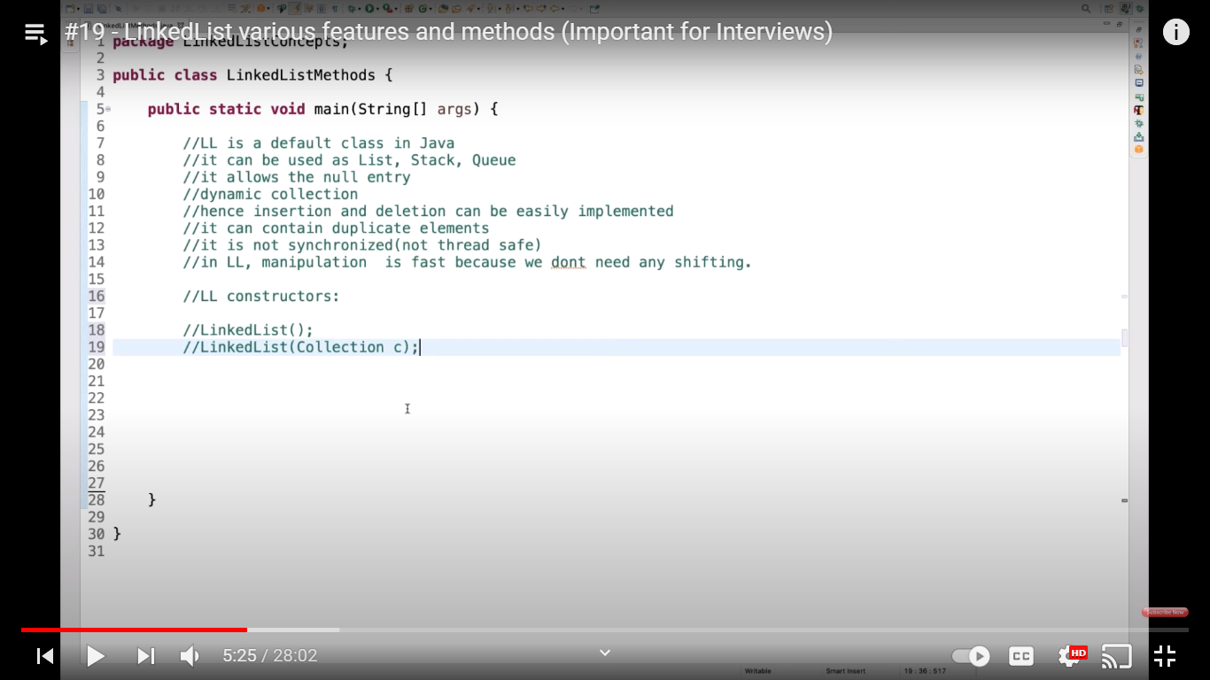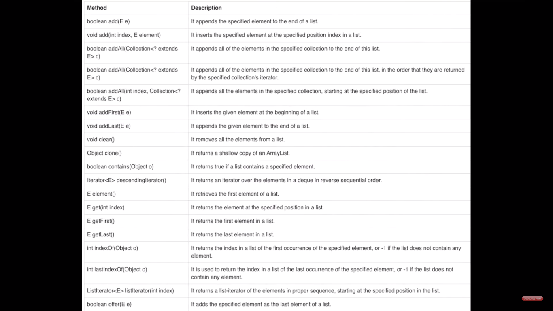

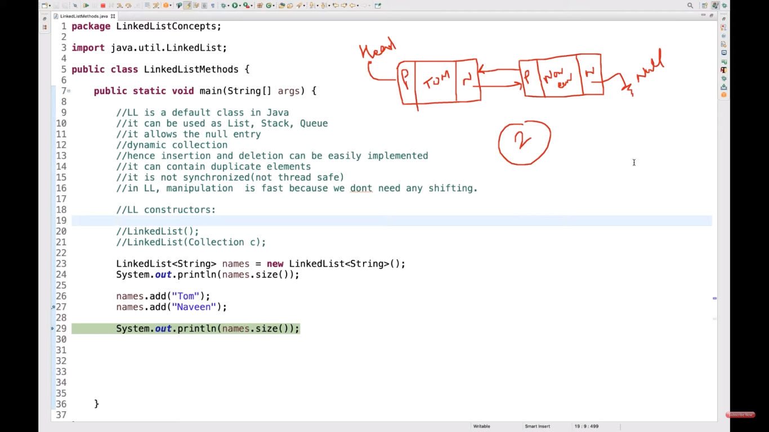

Vector:

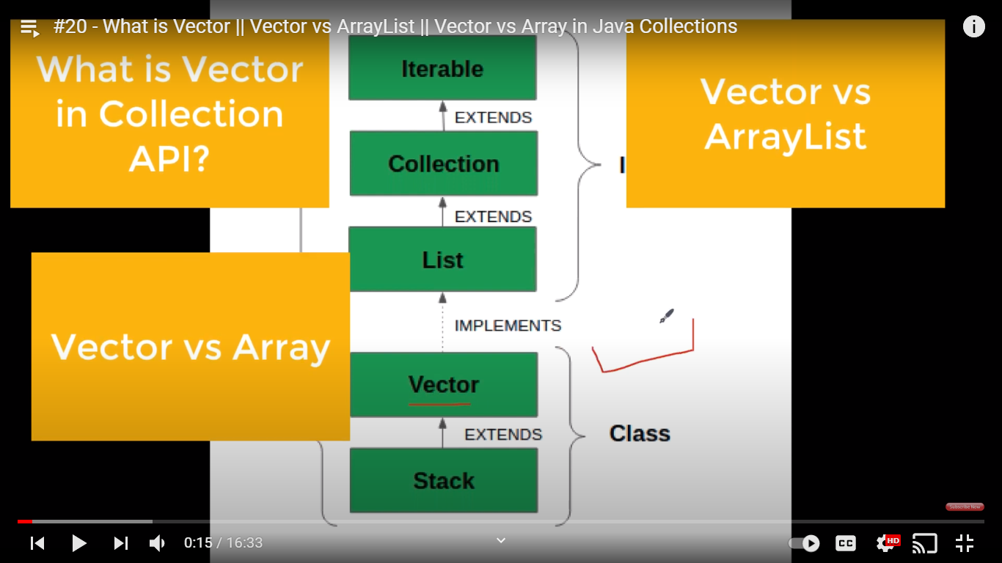

**Vector** vec = new **Vector**();

It creates an empty **Vector** with the **default initial capacity** of 10. It means the **Vector** will be re-sized when the 11th elements needs to be inserted into the **Vector**. Note: By **default vector** doubles its **size**.

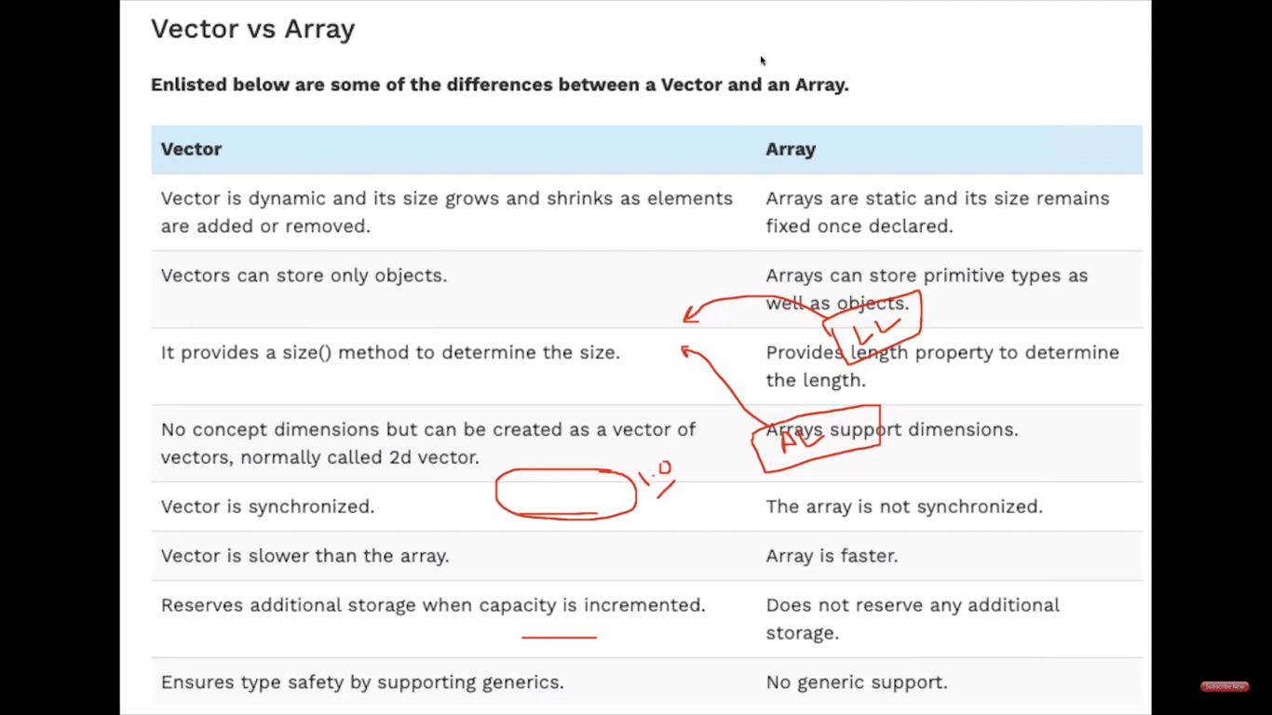

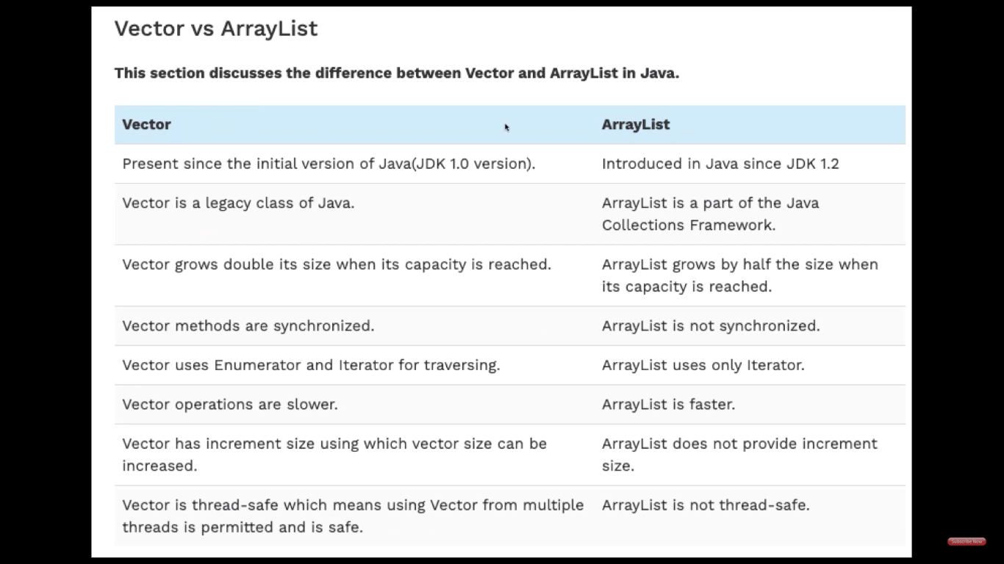

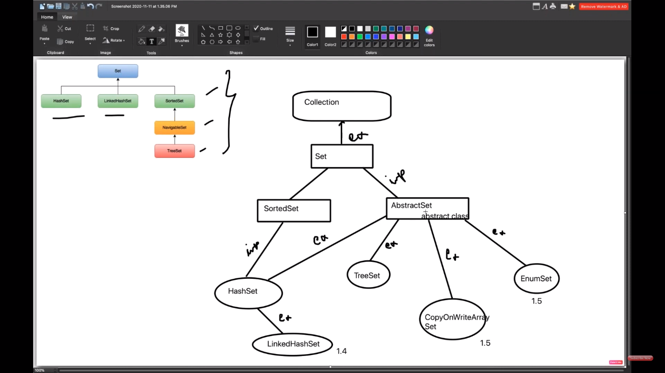

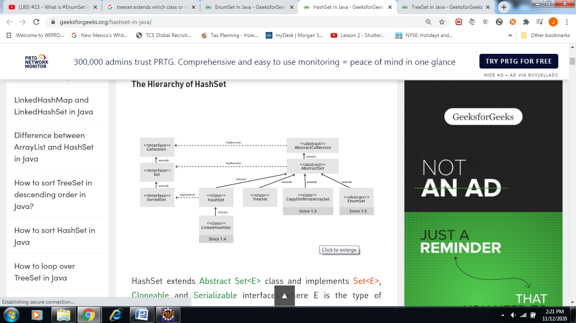

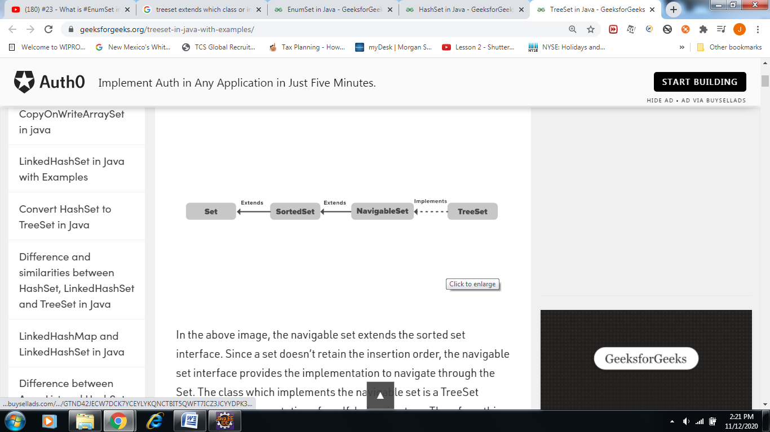

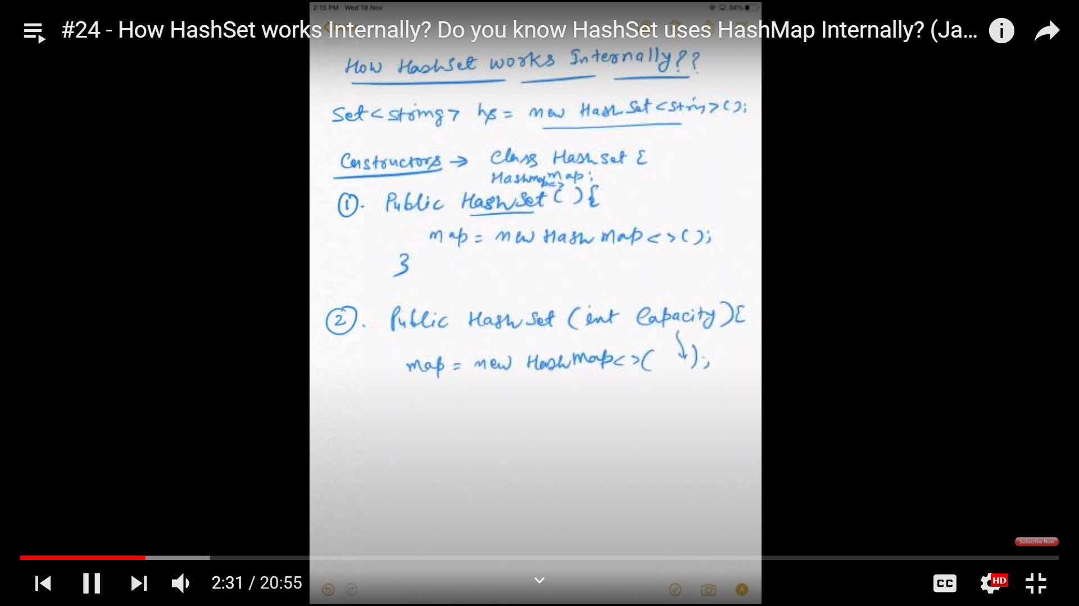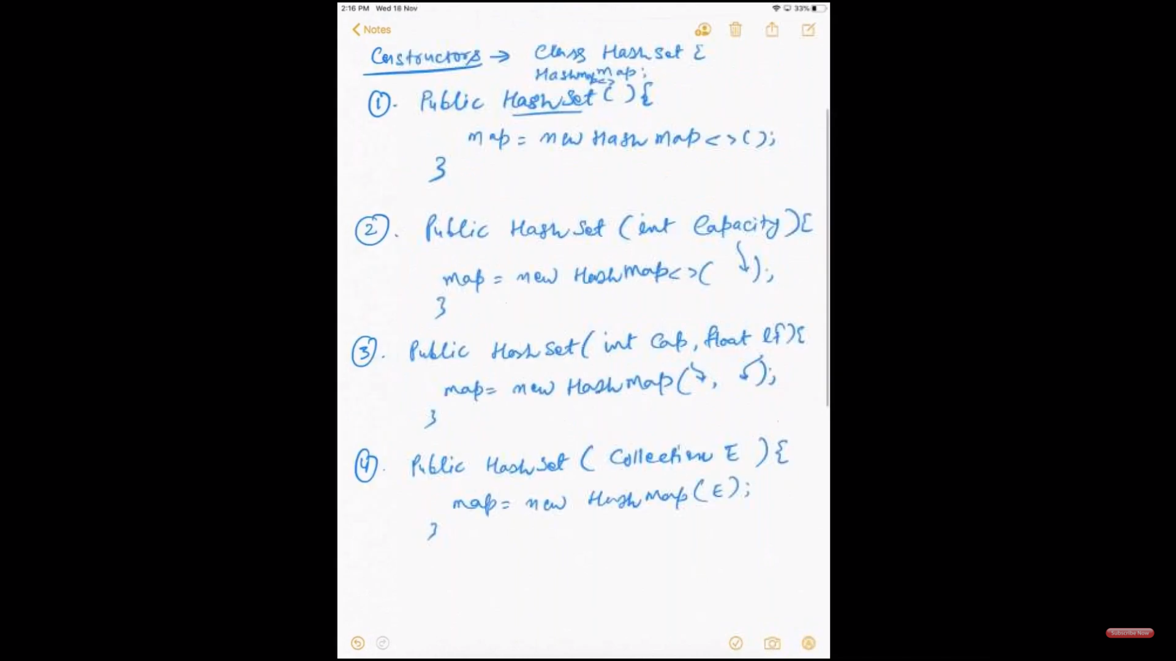 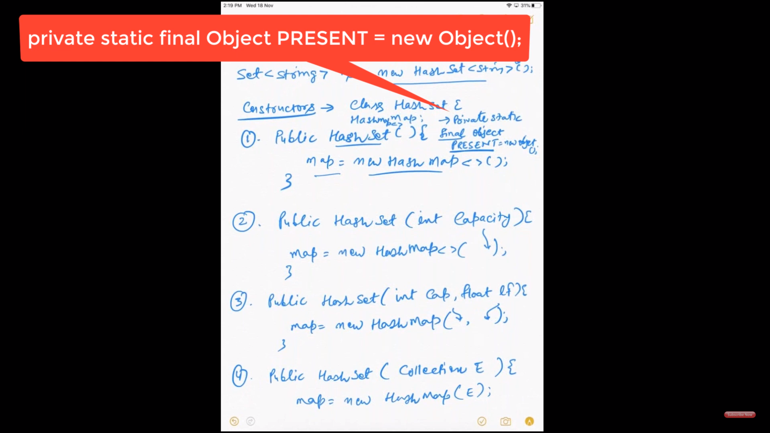

1. If map.put(key, value) returns *null*, then the statement “map.put(e, PRESENT) == null” will return *true* and element is added to the HashSet(internally HashMap).
2. If map.put(key, value) returns old value of the key, then the statement “map.put(e, PRESENT) == null” will return *false* and element is not added to the HashSet(internally HashMap).

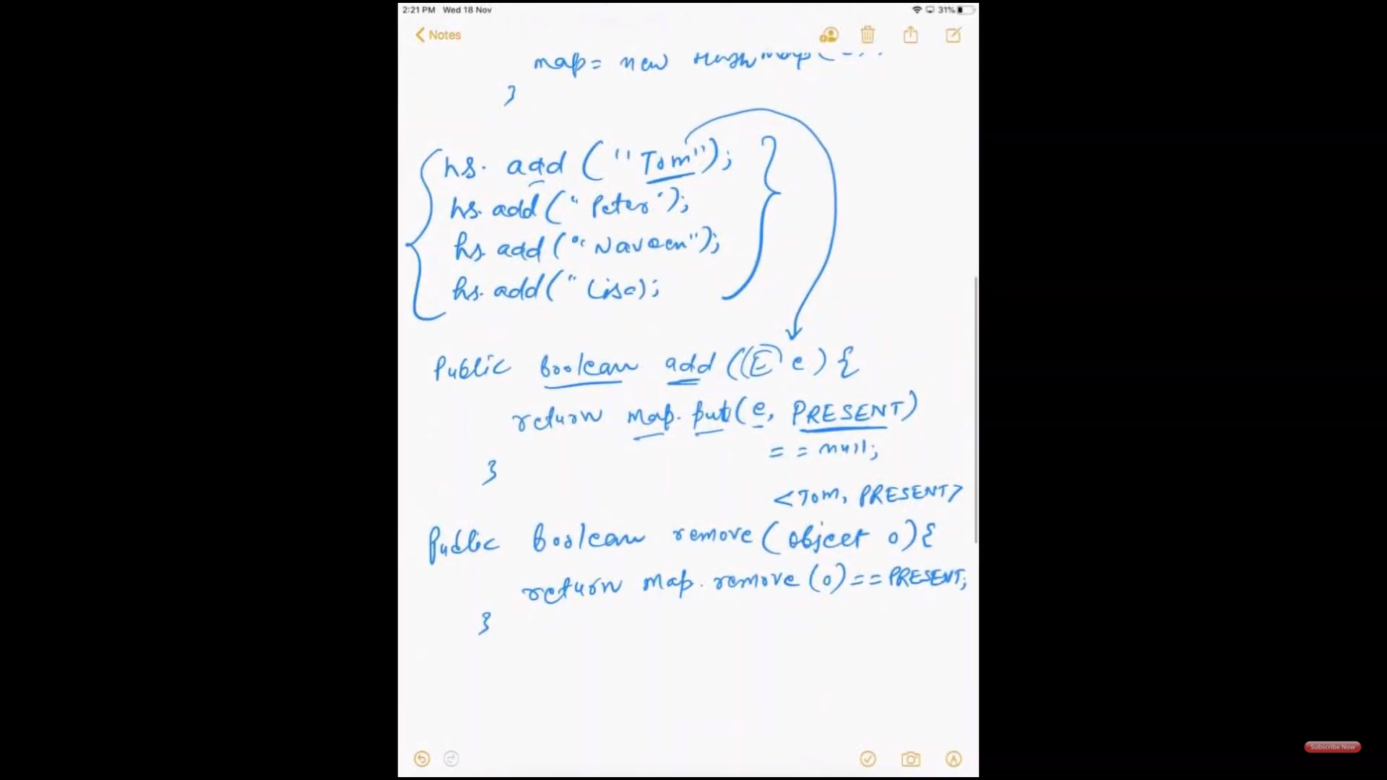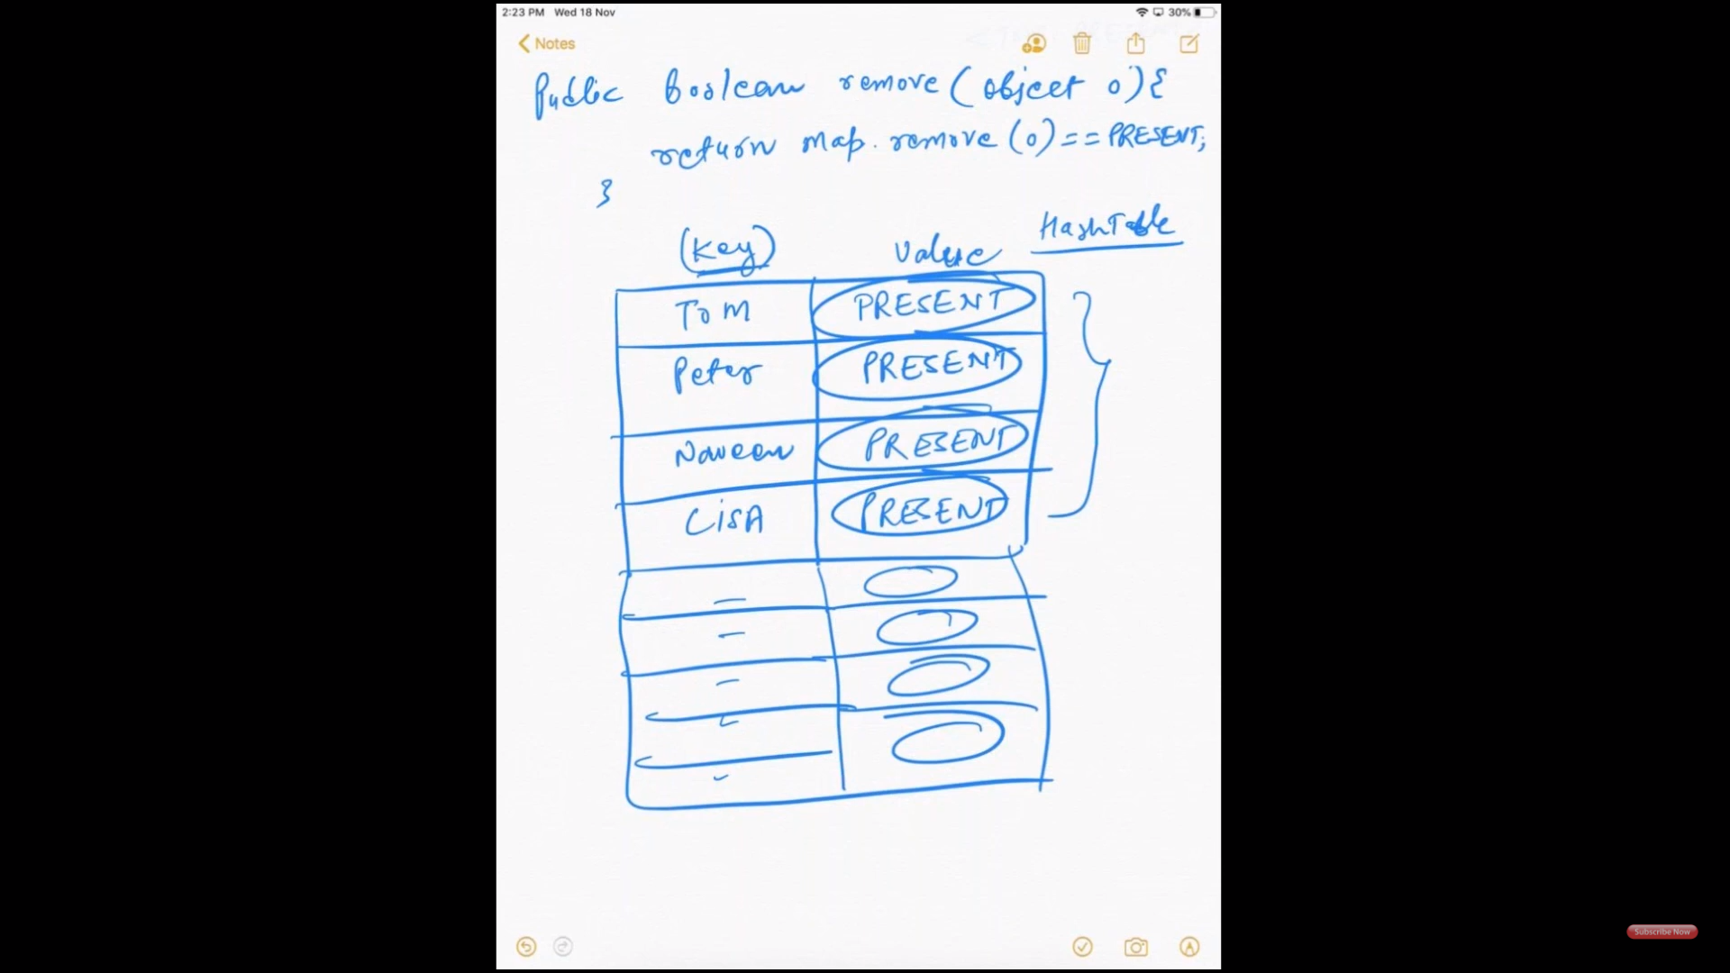

Java8: